

July 18, 2021 + 10:00am

Welcome to First Presbyterian,
whether this is your first visit or you are a regular worshiper,
we are happy you are here. Together let us praise our Triune God.

THE GATHERING

WELCOME
This is the day the Lord has made,
Let us rejoice and be glad in it, Alleluia!!

PRAYERS & PRAISES

+ PASSING THE PEACE

PRELUDE

+ CALL TO WORSHIP
Praise to our Triune God, whose Word and actions reveal power,
love and grace to the world.
O God your people praise you.
We are saved by the grace of Jesus Christ,
sustained by God’s mercies and equipped by the Spirit.
God, we are grateful to be entrusted with the privilege of
sharing about your love and grace with the world.
Thank you God for preparing equipping
and sending us into the world.
Let us praise our God, Amen.

+ UNISON PRAYER OF ADORATION
God of grace, you have given us minds to know you, hearts to love you, and voices to sing your praise. Fill us with your Spirit that we may celebrate your glory and worship you in spirit and in truth through Jesus Christ, our Lord. Amen.

+ HYMN OF PRAISE “To God Be the Glory” #485

CALL TO CONFESSION

UNISON PRAYER OF CONFESSION
O God, you call and equip us to be your agents of hope, however we often think we are entitled to grace rather than remember it is your gift given in love. Forgive our sin of failing to see the pain and hurt in the world around us, forgive our disobedience and short sightedness, our failure to offer grace to others. Help us spend ourselves joyfully in your service; proclaiming the Good News of salvation, lifting burdens of fear and shame, cultivating talents, achieving justice, bearing fruit of righteousness, empowered by the Spirit to bring miracles to life.

SILENT PRAYER OF CONFESSION

ASSURANCE OF PARDON

+ RESPONSE “Alleluia, Alleluia! Give Thanks” #106
(Refrain 2X)
Refrain: Alleluia, alleluia! Give thanks to the risen Lord.
Alleluia, alleluia! Give Praise to His Name.

THE WORD

PRAYER FOR ILLUMINATION

SCRIPTURE READINGS
Old Testament: Psalm 130
New Testament: Ephesians 2:1-10

This is the Word of the Lord
Thanks be to God.

SERMON “G.R.A.C.E.”

+ HYMN OF RESPONSE “Amazing Grace” #280

THE THANKSGIVING

PRAYERS OF THE PEOPLE

THE LORD’S PRAYER
Our Father, who art in heaven, hallowed be thy name. Thy kingdom come, thy will be done, on earth as it is in heaven. Give us this day our daily bread; and forgive us our debts, as we forgive our debtors; and lead us not into temptation but deliver us from evil. For thine is the kingdom, and the power, and the glory forever. Amen.

CALL TO OFFERING

OFFERTORY
Please place your offering in the box on the table
at the rear of the sanctuary.

+ DOXOLOGY “Glory Be to the Father” #579
Glory to the Father, and to the Son, and to the Holy Ghost;
As it was in the beginning, is now, and ever will be,
world without end. Amen. Amen.

+ UNISON PRAYER OF DEDICATION
God, receive these gifts –
and give us open hands.
Fill our lives –
and give us open hearts.
Touch us with prophecy –
and give us open minds.
Bless this church –
give us open doors, welcoming friends
and strangers alike; Amen.

THE SENDING

+ SENDING HYMN “I Know Whom I Have Believed” back cover

+ BENEDICTION

+ RESPONSE “Go with Us Lord” #535
Go with us, Lord, and guide the way
Through this and every coming day,
That in Your Spirit strong and true
Our lives may be our gift to you.

+ POSTLUDE

+ Please stand if you are able and comfortable.

Music - Permission to print hymn text, podcast/stream the music in this service obtained from ONE LICENSE with license #A-727318. All rights reserved. Some music is in the public domain.

PARTICIPATING IN THE SERVICE
Pastor The Rev.Teresa Bartlett
Lector/Greeters Kent & Jodi Pulfer
Accompanist Jane O’Leary
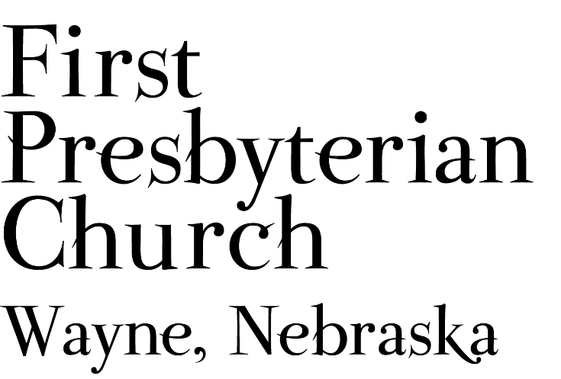
If you are a guest we invite you to return and worship with us often. If you don't have a church home, please consider our church family your church family.

PRAYER CONCERNS
Hold in Prayer: Continued prayers for healing for Marian Simpson. Eric Liska, Jan and Ken Liska. Philomena (sister of Jackie Owens and Wayne), Jackie’s brother, both in hospice care. Diane Confer, Joseph Woerdman. Remember Shea Abraham serving in Jordan and all our military personnel. Remember those impacted by recent the recent storm and damages to property and electrical outages.

FPC CHURCH WEEK
Sunday 10:00am Worship

fpcwayne@gmail.com + 402-375-2669 + fpcwayne.com
find us on Facebook at First Presbyterian Church - Wayne, Nebraska

ANNOUNCEMENTS
- Have you ever thought to yourself during the Christmas season “I wish I didn’t have so much to do so I could enjoy the Christmas story and music without a long to-do list in my head?” July 25th we will celebrate Christmas in July. We will be singing Christmas carols and hearing familiar Scriptures. Plan to join us for worship.
- The Session will not meet in July.
- Communion will be celebrated August 15th.
- Pastor Teresa will be on study leave July 26th through August 2nd. The pulpit will be filled as follows:
  - August 1st, The Reverend Kathleen Splitt
  - August 8th, The Homestead Presbyterian Women’s Leadership Team
- Thank you to all who have been mowing the church lawn. We need volunteers for July and August. We need a mower for the upcoming week (July 19-24). You can sign-up on-line, in Fellowship Hall on the Opportunity Table or contact the office. Thank you!
- At their May meeting the Session reviewed FPC’s COVID practices and determined FPC could move into Phase Three of our three phase plan formulated last spring. Considering recent announcements by the CDC and the Governor, FPC will move into a mask optional practice. This does not mean there is no need for caution rather that each individual or family can make their own determination regarding the wearing of masks based on their health and comfort level. We will continue to maintain social distancing during worship in the sanctuary and recording attendees. Hand sanitizer and masks will be available. Access to Zoom will continue for those who desire to worship in that manner. We will not be resuming coffee fellowship at this time; you are encouraged to visit outside following worship. The Session and Pastor Teresa thank everyone for their past co-operation and hope the transition to this new practice will move smoothly.



FPC service recordings can be found at:
Facebook @ First Presbyterian Church – Wayne, Nebraska
Our website @ fpcwayne.com
YouTube @ fpc of Wayne Nebraska

There will be no ZOOM component for Worship
on August 1st or August 8th.
The weekly bulletin is now being posted to the FPC website
at https://fpcwayne.com/

