

July 25, 2021 + 10:00am

Welcome to First Presbyterian,
whether this is your first visit or you are a regular worshiper,
we are happy you are here. Together let us praise our Triune God.

THE GATHERING

WELCOME
The Word became flesh to live among us;
We have seen the glory of God in the child in the manger.

PRAYERS & PRAISES

+ PASSING THE PEACE

PRELUDE “There’s a Song in the Air”

+ CALL TO WORSHIP “O Come, All Ye Faithful” #41

+ PRAYER OF ADORATION

CALL TO CONFESSION

UNISON PRAYER OF CONFESSION
God of grace and truth, in Jesus Christ you came among us, a light shining in darkness. We confess that we have not welcomed the light, or trusted good news to be good. We have closed our eyes to glory in our midst expecting little, and hoping for less. Forgive our doubt, renew our hope, so we may receive the fullness of your grace, and live in the truth of Christ the Lord.

SILENT PRAYER OF CONFESSION

ASSURANCE OF PARDON

+ RESPONSE “O Little Town of Bethlehem” #43
Verse 4
O holy Child of Bethlehem, descend to us, we pray;
Cast out our sin and enter in, be born in us today.
We hear the Christmas angels, the great glad tidings tell;
O come to us, abide with us, Our Lord Emmanuel!

THE WORD

SUNG PRAYER FOR ILLUMINATION #327
“O Word of God Incarnate” Verse 1
O Word of God incarnate, O Wisdom from on high,
O Truth unchanged, unchanging, O Light of our dark sky,
We praise You for the radiance that from the hallowed page,
A lantern to our footsteps, shines on from age to age.

GOSPEL READING: Luke 1:26-38

CONGREGATIONAL HYMN “Come, Thou Long Expected Jesus” #2

GOSPEL READING: Luke 2:1-7

HYMN “Infant Holy, Infant Lowly” #37

GOSPEL READING: Luke 2: 8-20

This is the Word of the Lord
Thanks be to God.

HYMN “While Shepherds Watched Their Flocks” #58
Verses 1-3 & 6
MEDITATION

HYMN “It Came Upon the Midnight Clear” #38
Verses 1-2 & 4

*A CHRISTMAS CREED by Walter Russell Bowie (Adapted)
I believe in Jesus Christ and the beauty
of the gospel begun in Bethlehem.
I believe in the one whose spirit glorified a little town;
and whose spirit still brings music to persons
all over the world In towns both large and small.
I believe in the one for whom the crowded inn could
find no room,
I believe in the one whom the rulers of the earth
ignored and the proud people could
never understand; whose life was
among common people, whose welcome
came from persons of hungry hearts.
I believe in the one who proclaimed the love of
God to be invincible.
I believe in the one whose modest home in
Nazareth had love for its only wealth,
who looked at persons and made them see
what God’s love saw in them,
who by love brought sinners back to purity,
and lifted human weakness up to meet the
strength of God.
I believe in God who gives us the best of himself.
I believe in Jesus, the son of the living God,
born in Bethlehem,
for me and for the world.
Thanks be to God, who has met us in Jesus. Amen.

+ HYMN “What Child Is This” #53

THE THANKSGIVING

PRAYERS OF THE PEOPLE

THE LORD’S PRAYER
Our Father, who art in heaven, hallowed be thy name. Thy kingdom come, thy will be done, on earth as it is in heaven. Give us this day our daily bread; and forgive us our debts, as we forgive our debtors; and lead us not into temptation but deliver us from evil. For thine is the kingdom, and the power, and the glory forever. Amen.

CALL TO OFFERING

OFFERTORY
Please place your offering in the box on the table
at the rear of the sanctuary.

+ DOXOLOGY (Tune: Old Hundredth) #591
Praise God the Source of life and birth.
Praise God the Word, who came to earth.
Praise God the Spirit, holy flame.
All glory, honor to God’s name. Amen.

+ PRAYER OF DEDICATION

THE SENDING

+ SENDING HYMN “Joy to the World!“ #40

UNISON CLOSING PRAYER
Gracious God, you sent your Son, Jesus, to be our Savior: our light in the midst of darkness, our hope in the face of threats, our peace amid turmoil. In your Word we have seen him and know that your promises are true. Send us forth this day to live in hope and peace, until we gather again, we ask in the name of Jesus, the Lord. Amen.

+ BENEDICTION

+ RESPONSE “Go, Tell It on the Mountain” #29
Verse 3
Go, tell it on the mountain over the hills and everywhere;
Go, tell it on the mountain that Jesus Christ is born!
Down in a lowly manger the humble Christ was born,
And God sent us salvation that blessed Christmas morn.
Go, tell it on the mountain, over the hills and everywhere;
Go, tell it on the mountain that Jesus Christ is born!

+ POSTLUDE

+ Please stand if you are able and comfortable.

Music - Permission to print hymn text, podcast/stream the music in this service obtained from ONE LICENSE with license #A-727318. All rights reserved. Some music is in the public domain.

PARTICIPATING IN THE SERVICE
Pastor The Rev.Teresa Bartlett
Lector Jim Curtiss
Accompanist Jane O’Leary
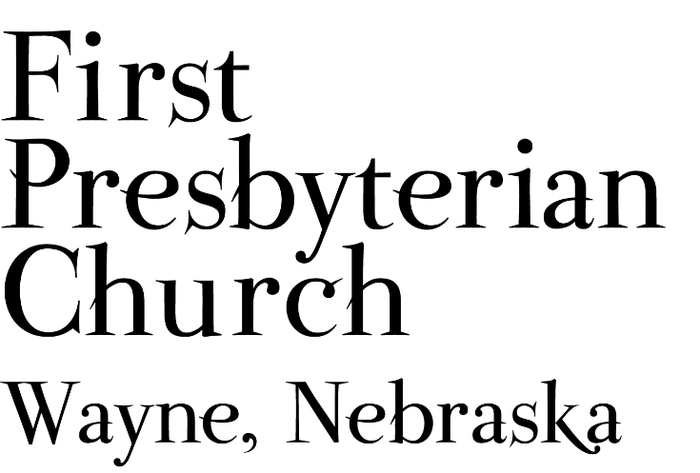
If you are a guest we invite you to return and worship with us often. If you don't have a church home, please consider our church family your church family.
FPC CHURCH WEEK
Sunday 10:00am Worship
Pastor Teresa will be on study leave July 26th - August 2nd.
Contact the church office for pastoral care needs.

PRAYER CONCERNS
Hold in Prayer: Continue to pray for healing and strength for Marian Simpson, Eric Liska, Jan and Ken Liska, others in our congregation who are confined to their homes or dealing with other health issues. Diane Confer (sister-in-law of Pastor Teresa), Joseph Woerdemann, friend of the congregation. Pray for Wayne, Jackie’s brother, in hospice care. Remember those who grieve this day. Remember Shea Abraham serving in Jordan and all our military personnel. Those impacted by recent the recent storms and damages to property and electrical outages. Fires and floods around the country, those impacted and rescue & service personnel.

ANNOUNCEMENTS
- The Session will not meet in July.
- Communion will be celebrated August 15th.
- Pastor Teresa will be on study leave July 26th -August 2nd. Contact the church office for pastoral care needs. The pulpit will be filled as follows:
  - August 1st, The Reverend Kathleen Splitt
  - August 8th, The Homestead Presbyterian Women’s Leadership Team
- Thank you to all who have been mowing the church lawn. We need mowers for the month of August. You can sign-up on-line, in Fellowship Hall on the Opportunity Table or contact the office. Thank you!
- Homestead Presbytery needs volunteers to serve on committees of the Presbytery. Currently there are openings on Disaster Response, Commission on Ministry, Committee on Preparation for Ministry and the Nominating Committee. Other positions will open on the Calvin Crest Board next year. If you are interested in serving the church as a member of one of these Committees please talk with Pastor Teresa. Your service to the wider church will be greatly appreciated.
- FPC is currently operating with mask-optional protocol. This does not mean there is no need for caution rather that each individual or family can make their own determination regarding the wearing of masks based on their health and comfort level. Hand sanitizer and masks continue to be available. The access to Zoom will continue for those who desire to worship in that manner. We will not be resuming coffee fellowship at this time; you are encouraged to visit outside following worship. The Session and Pastor Teresa thank everyone for their past co-operation and hope the transition to this practice will continue smoothly.



FPC service recordings can be found at:
Facebook @ First Presbyterian Church – Wayne, Nebraska
Our website @ fpcwayne.com
YouTube @ fpc of Wayne Nebraska

There will be no ZOOM component for Worship
on August 1st or August 8th.

The weekly bulletin is now being posted to the FPC website
at https://fpcwayne.com/

