

August 15, 2021 + 10:00am

Welcome to First Presbyterian,
whether this is your first visit or you are a regular worshiper,
we are happy you are here. Together let us praise our Triune God.

THE GATHERING

WELCOME
This is the day the Lord has made,
Let us rejoice and be glad in it, Alleluia!!

PRAYERS & PRAISES

+ PASSING THE PEACE

PRELUDE

+ CALL TO WORSHIP (Adapted from Psalm 105, Matthew 14)
Come, now is the time to worship
Now is the time to step forth in faith.
Give thanks to our God.
Sing of God’s praise and glory.
Seek the Lord.
Rejoice in God’s presence.
Come, now is the time to worship.

+ PRAYER OF ADORATION

+ HYMN OF PRAISE “Sanctuary” (repeat 2x)
Lord, prepare me to be a sanctuary,
pure and holy, tried and true.
With thanksgiving, I’ll be a living sanctuary for you.

CALL TO CONFESSION

UNISON PRAYER OF CONFESSION
Faithful One, you reach out to us with unbounded love. Forgive us for too easily sinking into sin. Forgive us when you call us forward in faith and we resist. When we realize we have taken our eyes off you and call out in humility, you extend your hands and raise us up with your mercy and grace. Eternal God, we give thanks that as your children through Jesus Christ we can be forgiven, renewed, and emboldened to share what Jesus has done for us.

SILENT PRAYER OF CONFESSION

ASSURANCE OF PARDON

+ RESPONSE “Alleluia, Alleluia! Give Thanks” #106
(Refrain 2X)
Refrain: Alleluia, alleluia! Give thanks to the risen Lord.
Alleluia, alleluia! Give Praise to His Name.

THE WORD

PRAYER FOR ILLUMINATION “Thy Word” Video Prayer

SCRIPTURES

OLD TESTAMENT : Psalm 133
NEW TESTAMENT: Ephesians 4:1-16

This is the Word of the Lord
Thanks be to God.

MEDITATION

HYMN OF RESPONSE “All Are Welcome/Let us Build a House”
(on back cover)

COMMUNION OF GOD’S PEOPLE

INVITATION TO THE TABLE

COMMUNION HYMN “Let Us Break Bread Together” #513
Let us break bread together on our knees;
let us break bread together on our knees.
Refrain: When I fall on my knees, with my face to the rising sun,
O Lord, have mercy on me.
Let us drink wine together on our knees;
let us drink wine together on our knees. [Refrain]
Let us praise God together on our knees;
let us praise God together on our knees. [Refrain]

THE PRAYER OF GREAT THANKSGIVING
The Lord be with you.
And, also with you.
Lift your hearts.
We lift them to the Lord.
Let us give thanks to the Lord our God
It is right to give our thanks and praise.

….Therefore, with all who love you, who surround us on every side, countless as heaven's stars, we praise you for our creation and our calling, with loving and joyful hearts.
Holy God, holy and merciful, holy, and just,
glory and goodness come from you.
Glory to you, most high and gracious God.
…. We thank you for his life, his death and resurrection. We look for his coming in glory and in him we give ourselves to you.
Christ has died, Christ has risen, Christ will come again.
God of love send your Holy Spirit upon these gifts, that as we receive this bread and cup, we shall by faith receive the body and blood of Christ. Called to follow Christ, help us to reconcile and unite, give us hope as we follow you. Let us pray as Jesus taught us…

THE LORD’S PRAYER
Our Father, who art in heaven, hallowed be thy name. Thy kingdom come, thy will be done, on earth as it is in heaven. Give us this day our daily bread; and forgive us our debts, as we forgive our debtors; and lead us not into temptation but deliver us from evil. For thine is the kingdom, and the power, and the glory forever. Amen.

WORDS OF INSTITUTION AND COMMUNION OF THE PEOPLE
….We remember Jesus gathered with his disciples before he gave himself up for us, took bread, blessed it and broke it, gave it to his friends, saying, 'Take, eat, this is my body which is broken for you. Do this to remember me.'
We take the bread and eat, remember, and believe that the body of our Lord Jesus Christ was given for the complete forgiveness of all our sins.
Thanks be to God.
The same night Jesus took the cup, he gave thanks and gave the cup to his disciples saying, 'This is the new covenant sealed by my blood. When you drink from it, do this in memory of me'.
We take the cup together as we drink, remember, and believe that the precious blood of our Lord Jesus Christ was shed for the complete forgiveness of all our sins.
Thanks be to God.

UNISON PRAYER OF THANKSGIVING
We bless you, O God, for gifts of bread and cup, for sustaining us in hope, every day of our lives. We pray for your strength to prepare us for your service as we offer to you lives of witness and worship in the world you have made. Through Christ, our Lord. Amen.

THE THANKSGIVING

CALL TO OFFERING

OFFERTORY
Please place your offering in the box on the table
at the rear of the sanctuary.

+ DOXOLOGY “Glory Be to the Father” #579
Glory to the Father, and to the Son, and to the Holy Ghost;
As it was in the beginning, is now, and ever will be,
world without end. Amen. Amen.

+ UNISON PRAYER OF DEDICATION
God, receive these gifts – and give us open hands.
Fill our lives – and give us open hearts.
Touch us with prophecy – and give us open minds.
Bless this church –open our doors to
welcome friends and strangers alike; Amen.

THE SENDING

+ SENDING HYMN “Called as Partners in Christ’s Service” #343

+ BENEDICTION

+ CONGREGATIONAL RESPONSE “Go with Us Lord” #535
Go with us, Lord, and guide the way
through this and every coming day,
That in Your Spirit strong and true
Our lives may be our gift to you.

+ POSTLUDE

+ Please stand if you are able and comfortable.

Music - Permission to print hymn text, podcast/stream the music in this service obtained from ONE LICENSE with license #A-727318. All rights reserved. Some music is in the public domain.
PARTICIPATING IN THE SERVICE
Pastor The Rev.Teresa Bartlett
Lector Taytum Sweetland
Accompanist Jane O’Leary
Technologist Mark Hammer
Greeter Nina Hammer
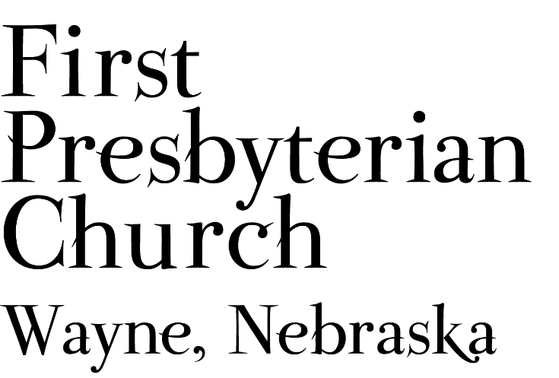
If you are a guest we invite you to return and worship with us often. If you don't have a church home, please consider our church family your church family.

FPC CHURCH WEEK
Sunday 10:00am Worship
Monday - Friday, August 16 - 20,
Pastor gives devotions at *5:40am KTCH 104.9 Moment for Living
Tuesday 4:30pm Deacons Meeting
Wednesday 3:30pm Pastor at
Kinship Pointe Chapel
Thursday “Word in Faith” runs in Wayne Herald
Saturday 10:00am Homestead Presbytery (Zoom)

PRAYER CONCERNS
Hold in Prayer: Continue to pray for healing and strength for Marian S., Eric L., Jan and Ken L., others in our congregation who are confined to their homes or dealing with other health issues. Diane C. (sister-in-law of Pastor Teresa), Joseph W., friend of the congregation. Remember those who grieve this day. Remember Shea Ab. serving in Jordan and all our military personnel. Remember those impacted by recent storms, flooding and fires, also rescue & service personnel. Pray for students, teachers, parents & school administrators as students return to school and college.

Thankful and Grateful
July 11, 2021
Dear Friends and Loved Ones,
As many of you know, my life has been full of the unexpected in recent months. On April 29, I fell while stepping off the curb in the Wal-Mart parking lot and managed to do some serious damage, including multiple fractures on both sides of my pelvis, skin damage to my lower right leg, a banged up elbow, and a nasty knot on the backside of my head. Time since then has been mostly spent in the hospital and a rehabilitation center, but I am pleased to report healing continues. My walking continues to improve and the lingering pain is less each day. My appointment with the orthopedic doctor this week went well and my fractures continue to heal as needed, but still several months before they are fully healed. My current goal is to continue improving my walking so that I can return home as soon as my doctors feel I am able, to continue my healing process there.
A special thank you for all of the cards, calls, prayers, and well-wishes I have received, and continue to receive, over the past few months. I enjoy hearing from all of you. Jeff brings me my mail regularly.
Love, Marian

(Handwritten note: “Thank you so much. I knew you were special people.”)

ANNOUNCEMENTS
- Deacons will meet August 17th in Fellowship Hall at 4:30 p.m.
- SAVE THE DATE FOR…. SUNDAE SUNDAY - Join us as we begin the new church year on September 12. We’ll gather for worship and following the service we will have ice cream and toppings during our SUNDAE SUNDAY Fellowship time.
- We need lawn mowing volunteers for August and September. You can sign-up on-line, in Fellowship Hall on the Opportunity Table or contact the office. Thank you to all who have been mowing the church lawn.
- The annual OSLC/FPC Golf Outing will take place Tuesday, August 24th beginning at 5:30 pm. It will be a scramble 4-person team format. You may assemble a team or be assigned to a team. The $12 cost includes 9-hole green fee, cart rental, prizes and a meal. For additional information contact Darrell Miller @ darrellmiller1218@gmail.com.
- Homestead Presbytery meeting via Zoom, August 21st.
- The Wayne Salvation Army Unit is looking for volunteers. The primary project is the November/December Bell Ringing project which funds other efforts such as the back to school back pack project. You don’t have to be a pastor to serve on the board. The group doesn’t meet every month, but meets at least quarterly. If interested contact Pastor Teresa. Thank-you for your consideration.
- Homestead Presbytery needs volunteers to serve on committees of the Presbytery. Currently there are openings on Disaster Response, Commission on Ministry, Committee on Preparation for Ministry and the Nominating Committee. Other positions will open on the Calvin Crest Board next year. If you are interested in serving the church as a member of one of these Committees please talk with Pastor Teresa. Your service to the wider church will be greatly appreciated.
- FPC is currently operating with mask-optional protocol. This does not mean there is no need for caution rather that each individual or family can make their own determination regarding the wearing of masks based on their health and comfort level. Hand sanitizer and masks continue to be available. The access to Zoom will continue for those who desire to worship in that manner. We will not be resuming coffee fellowship at this time; you are encouraged to visit outside following worship. The Session and Pastor Teresa thank everyone for their past co-operation and hope the transition to this practice will continue smoothly.


FPC service recordings can be found at:
Facebook @ First Presbyterian Church – Wayne, Nebraska
Our website @ fpcwayne.com
YouTube @ fpc of Wayne Nebraska

The weekly bulletin is now being posted to the FPC website
at https://fpcwayne.com/

