

August 22, 2021 + 10:00am

Welcome to First Presbyterian,
whether this is your first visit or you are a regular worshiper,
we are happy you are here. Together let us praise our Triune God.

THE GATHERING

WELCOME
This is the day the Lord has made,
Let us rejoice and be glad in it, Alleluia!!

PRAYERS & PRAISES

+ PASSING THE PEACE

PRELUDE

+ CALL TO WORSHIP (Composed by Beth Merrill Neel)
We gather today to worship the One who created us,
The One who calls us,
The One who equips us,
The One who loves us without end.
With joyful hearts,
Let us worship God.

+ PRAYER OF ADORATION

+ HYMN OF PRAISE “Let Us with a Gladsome Mind” #244

CALL TO CONFESSION (Composed by Beth Merrill Neel)

UNISON PRAYER OF CONFESSION (Composed by Beth Merrill Neel)
Gracious God, source of all life, Lord of mercy and grace, hear our prayer.
We come before you in need of healing:
The healing of our bodies and souls,
The healing of our relationships,
The healing of our pride and fear and apathy.
We know that with you, nothing is impossible, not even our healing,
Not even the restoration of the whole world.
We pray that you will heal us, that you will heal our world,
So that we will be freed to serve and love and dream and be,
As Christ calls us. Amen.

SILENT PRAYER OF CONFESSION

ASSURANCE OF PARDON

+ RESPONSE “Alleluia, Alleluia! Give Thanks” #106
(Refrain 2X)
Refrain: Alleluia, alleluia! Give thanks to the risen Lord.
Alleluia, alleluia! Give Praise to His Name.

THE WORD

PRAYER FOR ILLUMINATION

SCRIPTURE READINGS:
OLD TESTAMENT : Psalm 34:9-14 NIV
NEW TESTAMENT: Ephesians 5:15-20 NIV

This is the Word of the Lord
Thanks be to God.

SERMON “Urgency & Gratitude”

HYMN OF RESPONSE “Where Cross the Crowded Ways of Life”#408

THE THANKSGIVING

PRAYERS OF THE PEOPLE

THE LORD’S PRAYER
Our Father, who art in heaven, hallowed be thy name. Thy kingdom come, thy will be done, on earth as it is in heaven. Give us this day our daily bread; and forgive us our debts, as we forgive our debtors; and lead us not into temptation but deliver us from evil. For thine is the kingdom, and the power, and the glory forever. Amen.

CALL TO OFFERING

OFFERTORY
Please place your offering in the box on the table
at the rear of the sanctuary.

+ DOXOLOGY “Glory Be to the Father” #579
Glory to the Father, and to the Son, and to the Holy Ghost;
As it was in the beginning, is now, and ever will be,
world without end. Amen. Amen.

+ RESPONSIVE PRAYER OF DEDICATION
God, receive these gifts – and give us open hands.
Fill our lives – and give us open hearts.
Touch us with prophecy – and give us open minds.
Bless this church –open our doors to
welcome friends and strangers alike; Amen.

THE SENDING

+ SENDING HYMN “God of Grace and God of Glory” #420

+ BENEDICTION

+ CONGREGATIONAL RESPONSE “Go with Us Lord” #535
Go with us, Lord, and guide the way
through this and every coming day,
That in Your Spirit strong and true
Our lives may be our gift to you.

+ POSTLUDE

+ Please stand if you are able and comfortable.

Music - Permission to print hymn text, podcast/stream the music in this service obtained from ONE LICENSE with license #A-727318. All rights reserved. Some music is in the public domain.

PARTICIPATING IN THE SERVICE
Pastor The Rev.Teresa Bartlett
Lector/Greeter Kent Pulfer
Accompanist Jane O’Leary

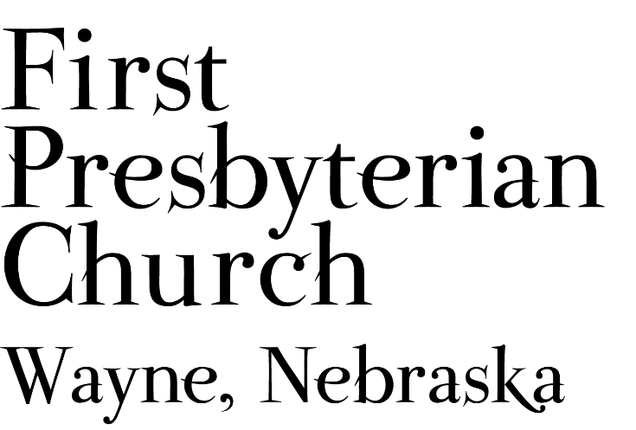
If you are a guest we invite you to return and worship with us often. If you don't have a church home, please consider our church family your church family.

FPC CHURCH WEEK
Sunday 10:00am Worship
Monday 7:00pm Session Meeting
Tuesday 5:30pm Golf Outing with OSLC

PRAYER CONCERNS

Hold in Prayer: Continued prayers for healing for Marty Hettinger (mother of Dawn Fuelberth), Jackie Owens, Marian Simpson, Jan and Ken Liska, Eric Liska, Diane Confer (sister-in-law to Pastor Teresa), and Joseph Woerdemann. Jim Curtiss, on his relocation closer to family. Remember Shea Abraham serving in Jordan and all our service personnel serving around the world. Pray for the residents of Haiti suffering from the earthquake and storm, those impacted by and fighting wildfires across the country.

ANNOUNCEMENTS
- The Presbytidings newsletter is available in electronic form on our FPC Website, and on our Facebook page. Paper copies are available at the back of the sanctuary and in Fellowship Hall.
- The Session will meet Monday, August 23, at 7:00 pm in Fellowship Hall, watch for the documents and treasurer’s report in your email.
- SAVE THE DATE FOR….
  - FPC GAME NIGHT - Attention young and old: First Presbyterian will host a “game night” on Sundays, beginning August 29th. You can choose between individual or team activities such as ring toss, ladder toss, croquet, and Kubb (a new “in” game becoming popular among young adults). We’ll have sidewalk chalk too. Bring your relatives and friends! Winter activities will include board games and puzzles indoors. If you’d like to be a spectator, bring a lawn chair. Contact Jane if you have questions or games to contribute. Mark your phones and planners for August 29th! We’ll start at 6:30pm and end at dusk.
  - SUNDAE SUNDAY - Join us as we begin the new church year on September 12. We’ll gather for worship and following the service we will have ice cream and toppings during our SUNDAE SUNDAY Fellowship time.
- We need lawn mowing volunteers for August/September beginning this week. You can sign-up on-line, in Fellowship Hall on the Opportunity Table or contact the office. Thank you to all who have been mowing the church lawn.
- The annual OSLC/FPC Golf Outing will take place Tuesday, August 24th beginning at 5:30 pm. It will be a scramble 4-person team format. You may assemble a team or be assigned to a team. The $12 cost includes 9-hole green fee, cart rental, prizes and a meal. For additional information contact Darrell Miller @ darrellmiller1218@gmail.com.

- Jim Curtiss will be moving to Omaha this week. See the church office for his new address. We wish you well, Jim! We’ll miss you.
- POTENTIAL BIBLE STUDY: As plans are being made for the upcoming church year 2021-2022. Pastor Teresa would like to know if there is an interest in the congregation for a monthly Bible Study? If so what day/evening of the week and what time would work into your schedule? There are a variety of options including the Presbyterian Women’s 2021-2022 “What My Grandmothers Taught Me” study. If you have interest in Bible study please let Pastor Teresa know and indicate what day and time would fit your schedule.
- The Wayne Salvation Army Unit is looking for volunteers. The primary project is the November/December Bell Ringing project which funds other efforts such as the back to school back pack project. You don’t have to be a pastor to serve on the board. The group doesn’t meet every month, but meets at least quarterly. If interested contact Pastor Teresa. Thank-you for your consideration.
- Homestead Presbytery needs volunteers to serve on committees of the Presbytery. Currently there are openings on Disaster Response, Commission on Ministry, Committee on Preparation for Ministry and the Nominating Committee. Other positions will open on the Calvin Crest Board next year. If you are interested in serving the church as a member of one of these Committees please talk with Pastor Teresa. Your service to the wider church will be greatly appreciated.
- FPC is currently operating with mask-optional protocol. This does not mean there is no need for caution rather that each individual or family can make their own determination regarding the wearing of masks based on their health and comfort level. Hand sanitizer and masks continue to be available. The access to Zoom will continue for those who desire to worship in that manner. We will not be resuming coffee fellowship at this time; you are encouraged to visit outside following worship. The Session and Pastor Teresa thank everyone for their past co-operation and hope the transition to this practice will continue smoothly.



FPC service recordings can be found at:
*Facebook @ First Presbyterian Church – Wayne, Nebraska
*Our website @ fpcwayne.com
*YouTube @ fpc of Wayne Nebraska

FPC Online Worship Bulletins cab be found at:
https://fpcwayne.com/fpc-wayne-worship-bulletins/

