

August 29, 2021 + 10:00am

Welcome to First Presbyterian,
whether this is your first visit or you are a regular worshiper,
we are happy you are here. Together let us praise our Triune God.

THE GATHERING

WELCOME
This is the day the Lord has made,
Let us rejoice and be glad in it, Alleluia!!

PRAYERS & PRAISES

+ PASSING THE PEACE

PRELUDE “Christ Is Made the Sure Foundation”
+ CALL TO WORSHIP (based on Romans 8:29-31)
Brothers and sisters, the extravagant love of God has called us together.
For long before we were even aware of it, God knew us.
God had already chosen us to be part of His family—children of God!
And having chosen us, he called us;
and having called us, he justified us;
and having justified us, he gave us his glory!
What extravagant love is this!
So come, let’s worship God together!

+ PRAYER OF ADORATION

+ HYMN OF PRAISE “God is Here” #461

CALL TO CONFESSION

UNISON PRAYER OF CONFESSION
Triune God, forgive us for being unsure of your steadfast love, we come before you with trust and anxiety. It is easy to choose the path of our own indulgence instead of the way of discipleship. We like to feel comfortable and secure rather than risk the disfavor of others or the consequences of standing up against wrong. Too often we fail to resist evil, injustice and alienation around us to stand against things that harm and divide your children. O God draw us by your Spirit into your forgiving, renewing grace through Christ. We pray that you would help us to stand firm in our faith, to see ourselves as we are, give us vision and steadfastness to live as your disciples.

SILENT PRAYER OF CONFESSION

ASSURANCE OF PARDON
+ RESPONSE “Alleluia, Alleluia! Give Thanks” #106
(Refrain 2X)
Refrain: Alleluia, alleluia! Give thanks to the risen Lord.
Alleluia, alleluia! Give Praise to His Name.

THE WORD

PRAYER FOR ILLUMINATION

SCRIPTURE READINGS:
OLD TESTAMENT : Joshua 24:1-2a, 14-24
NEW TESTAMENT: Ephesians 6:10-20

This is the Word of the Lord
Thanks be to God.

SERMON “Standing Firm”

HYMN OF RESPONSE “Standing on the Promises” back cover

THE THANKSGIVING

PRAYERS OF THE PEOPLE

THE LORD’S PRAYER
Our Father, who art in heaven, hallowed be thy name. Thy kingdom come, thy will be done, on earth as it is in heaven. Give us this day our daily bread; and forgive us our debts, as we forgive our debtors; and lead us not into temptation but deliver us from evil. For thine is the kingdom, and the power, and the glory forever. Amen.

CALL TO OFFERING

OFFERTORY
Please place your offering in the box on the table
at the rear of the sanctuary.

+ DOXOLOGY “Glory Be to the Father” #579
Glory to the Father, and to the Son, and to the Holy Ghost;
As it was in the beginning, is now, and ever will be,
world without end. Amen. Amen.

+ RESPONSIVE PRAYER OF DEDICATION
God, receive these gifts – and give us open hands.
Fill our lives – and give us open hearts.
Touch us with prophecy – and give us open minds.
Bless this church –open our doors to
welcome friends and strangers alike; Amen.

THE SENDING

+ SENDING HYMN “The Church’s One Foundation” #442

+ BENEDICTION

+ CONGREGATIONAL RESPONSE “Go with Us Lord” #535
Go with us, Lord, and guide the way
through this and every coming day,
That in Your Spirit strong and true
Our lives may be our gift to you.

+ POSTLUDE

+ Please stand if you are able and comfortable.
Music - Permission to print hymn text, podcast/stream the music in this service obtained from ONE LICENSE with license #A-727318. All rights reserved. Some music is in the public domain.

PARTICIPATING IN THE SERVICE
Pastor The Rev. Teresa Bartlett
Lector/Greeter Karen Johnson
Accompanist Jane O’Leary
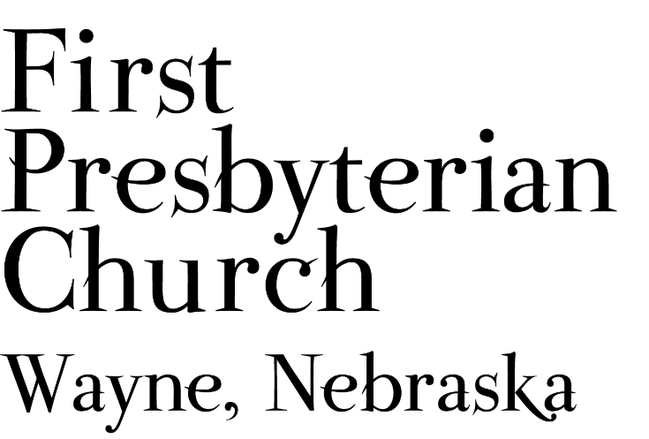
If you are a guest we invite you to return and worship with us often. If you don't have a church home, please consider our church family your church family.

FPC CHURCH WEEK
Sunday 10:00am Worship
6:30pm FPC Game Night

PRAYER CONCERNS
Hold in Prayer: Continued prayers for healing for Jackie Owens, Marty Hettinger (mother of Dawn Fuelberth), Marian Simpson, Jan and Ken Liska, Eric Liska, Diane Confer (sister-in-law to Pastor Teresa), and Joseph Woerdemann. Jim Curtiss, on his relocation closer to family. Remember Shea Abraham serving in Jordan and all our service personnel serving around the world. All those impacted by the earthquake and storms in Haiti, the fires in our country and all the firefighters working to control them. All those who have been displaced due to the fires. All our students, teachers, administrators & parents at all levels as school resumes.

ANNOUNCEMENTS
  - FPC GAME NIGHT - Attention young and old: tonight is “game night”. You can choose between individual or team activities such as ring toss, ladder toss, croquet, and Kubb (a new “in” game becoming popular among young adults). We’ll have sidewalk chalk too. Bring your relatives and friends! If you’d like to be a spectator, bring a lawn chair. Contact Jane if you have questions or games to contribute. We’ll start at 6:30pm and end at dusk.
  - Communion will be celebrated September 12th.
  - SAVE THE DATE FOR…SUNDAE SUNDAY - Join us as we begin the new church year on September 12. We’ll gather for worship and following the service we will have ice cream and toppings during our SUNDAE SUNDAY Fellowship time.
  - Congratulations to Taytum Sweetland who has been nominated as a Wayne High School Homecoming Candidate. Good luck, Taytum!
- We need lawn mowing volunteers for September. You can sign-up on-line, in Fellowship Hall on the Opportunity Table or contact the office. Thank you to all who have been mowing the church lawn.
- Coffee Fellowship will resume in September we will need fellowship hosts to prepare refreshments. Please sign up in Fellowship Hall or contact Jenny. September 19th and 26th hosts are needed.
- Jim Curtiss has moved to Omaha. Ask at the office if you would like his new address.
- Grace Lutheran is hosting a free Country and Gospel Music Concert at the Willow Bowl on September 12th from 5pm to 7pm. It is a FREE concert by Jake Gill. He was a contestant on The Voice, and many other contests and has performed with Jason Aldean and other country stars. Free will donation will help cover expenses and help fund participants for the upcoming National Youth Gathering.
- POTENTIAL BIBLE STUDY: As plans are being made for the upcoming church year 2021-2022. Pastor Teresa would like to know if there is an interest in the congregation for a monthly Bible Study? If so what day/evening of the week and what time would work into your schedule?
- The Wayne Salvation Army Unit is looking for volunteers. The primary project is the November/December Bell Ringing project which funds other efforts such as the back to school back pack project. You don’t have to be a pastor to serve on the board. The group doesn’t meet every month, but meets at least quarterly. If interested contact Pastor Teresa. Thank-you for your consideration.
- Homestead Presbytery needs volunteers to serve on committees of the Presbytery. Currently there are openings on Disaster Response, Commission on Ministry, Committee on Preparation for Ministry and the Nominating Committee. Other positions will open on the Calvin Crest Board next year. If you are interested in serving the church as a member of one of these Committees please talk with Pastor Teresa. Your service to the wider church will be greatly appreciated.
- FPC is currently operating with mask-optional protocol. This does not mean there is no need for caution rather that each individual or family can make their own determination regarding the wearing of masks based on their health and comfort level. Hand sanitizer and masks continue to be available. The access to Zoom will continue for those who desire to worship in that manner. We will not be resuming coffee fellowship at this time; you are encouraged to visit outside following worship. The Session and Pastor Teresa thank everyone for their past co-operation and hope the transition to this practice will continue smoothly.

FPC service recordings can be found at:
*Facebook @ First Presbyterian Church – Wayne, Nebraska
*Our website @ fpcwayne.com
*YouTube @ FPC of Wayne Nebraska
FPC Online Worship Bulletins can be found at:
https://fpcwayne.com/fpc-wayne-worship-bulletins/
Standing on the promises of Christ my King
Author: Russell Kelso Carter (1886)
(Public Domain)

1 Standing on the promises of Christ, my King,
Through eternal ages let his praises ring;
Glory in the highest, I will shout and sing,
Standing on the promises of God.

Refrain:
Standing, standing,
Standing on the promises of God, my Savior;
Standing, standing,
I'm standing on the promises of God.

2 Standing on the promises that cannot fail.
When the howling storms of doubt and fear assail,
By the living Word of God I shall prevail,
Standing on the promises of God. [Refrain]

3 Standing on the promises of Christ, the Lord,
Bound to him eternally by love's strong cord,
Overcoming daily with the Spirit's sword,
Standing on the promises of God. [Refrain]

4 Standing on the promises I cannot fall,
List'ning ev'ry moment to the Spirit's call,
Resting in my Savior as my all in all,
Standing on the promises of God. [Refrain]

