

August 8, 2021 + 10:00am

Welcome to First Presbyterian,
whether this is your first visit or you are a regular worshiper,
we are happy you are here. Together let us praise our Triune God.

THE GATHERING
WELCOME
God is good, all the time,
All the time God is good.

PRAYERS & PRAISES

+ PASSING THE PEACE
The peace of Christ be with you
and also with you.

PRELUDE

+ CALL TO WORSHIP
Triune God, thank you that you have made the way of love
known through your son Jesus Christ.
We pray that you would reveal this great love to us all
today as we gather to worship.

+ PRAYER OF ADORATION

+ HYMN OF PRAISE “Be Thou My Vision” #339

CALL TO CONFESSION

UNISON PRAYER OF CONFESSION
O God, we confess that we often look back.
We look back on mistakes we have made, work left undone,
People we have hurt and excuses we have made.
We see these as things for which we feel guilty.
We overwhelm ourselves with regret.

Free us, O God, from self-condemnation that immobilizes us.
Allow us to remember that you call us to look back,
to remember those times of joy,
to remember those people who were kind and compassionate,
to remember that we did the best we were able to do,
to remember that in Christ our past is transformed,
to remember that you journey with us each day of our life.
May we continue to grow in grace and truth.

SILENT PRAYER OF CONFESSION

ASSURANCE OF PARDON

+ RESPONSE “Alleluia, Alleluia! Give Thanks” #106
(Refrain 2X)
Refrain: Alleluia, alleluia! Give thanks to the risen Lord.
Alleluia, alleluia! Give Praise to His Name.

THE WORD

PRAYER FOR ILLUMINATION

SCRIPTURE READING: Matthew 5:1-10

This is the Word of the Lord
Thanks be to God.

MEDITATION “Blessed by God” Terri Sherman

MINUTE FOR MISSION Christy Abraham

+ HYMN OF RESPONSE “Here I Am, Lord” #525

THE THANKSGIVING

PRAYERS OF THE PEOPLE

THE LORD’S PRAYER
Our Father, who art in heaven, hallowed be thy name. Thy kingdom come, thy will be done, on earth as it is in heaven. Give us this day our daily bread; and forgive us our debts, as we forgive our debtors; and lead us not into temptation but deliver us from evil. For thine is the kingdom, and the power, and the glory forever. Amen.

CALL TO OFFERING
OFFERTORY
Please place your offering in the box on the table
at the rear of the sanctuary.

+ DOXOLOGY “Glory Be to the Father” #579
Glory to the Father, and to the Son, and to the Holy Ghost;
As it was in the beginning, is now, and ever will be,
world with our end. Amen. Amen.

+RESPONSIVE PRAYER OF DEDICATION
God, receive these gifts
and give us open hands.
Fill our lives
and give us open hearts.
Touch us with prophecy
and give us open minds.
Bless this church, by the Spirit open our doors
welcoming friends and strangers alike. Amen.

THE SENDING

+ SENDING HYMN “Will You Come and Follow Me” Back page

+ BENEDICTION

+ RESPONSE “Go with Us Lord” #535
Go with us, Lord, and guide the way
Through this and every coming day,
That in Your Spirit strong and true
Our lives may be our gift to you.
+ POSTLUDE

+ Please stand if you are able and comfortable.

Music - Permission to print hymn text, podcast/stream the music in this service obtained from ONE LICENSE with license #A-727318. All rights reserved. Some music is in the public domain.
PARTICIPATING IN THE SERVICE
Pastor Homestead Presbyterian Women
Leadership Team
Accompanist Jane O’Leary
Greeter Jean and Phil Griess
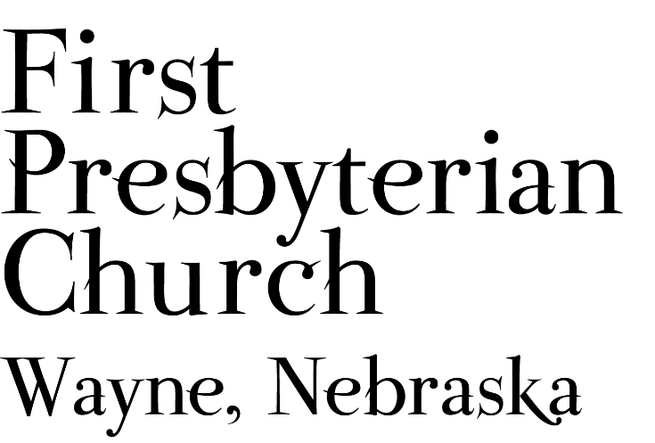
If you are a guest we invite you to return and worship with us often. If you don't have a church home, please consider our church family your church family.
FPC CHURCH WEEK
Sunday 10:00am Worship

PRAYER CONCERNS
Hold in Prayer: Continue to pray for healing and strength for Marian S., Eric L., Jan and Ken L., others in our congregation who are confined to their homes or dealing with other health issues. Diane C (sister-in-law of Pastor Teresa), Joseph W., friend of the congregation. Remember those who grieve this day, the family of Ronda Rager, friend of the Food Pantry. Remember Shea A. serving in Jordan and all our military personnel. Remember those impacted by recent storms, flooding and fires, also rescue & service personnel.

ANNOUNCEMENTS
- Welcome to the Homestead Presbyterian Women Leadership Team and worship leaders, Terri Sherman and Christy Abraham.
- The Wayne Presbyterian Women have donated $150.00 to Haven House in response to the Homestead PW focus on shelters and in honor of the Leadership Team leading worship today.
- Pastor Teresa is taking a vacation day Sunday the 8th and will return to the office on August 10th.
- Communion will be celebrated on August 15th.
- Deacons will meet August 17th in Fellowship Hall at 4:30 p.m.
- We need lawn mowing volunteers for August and September. You can sign-up on-line, in Fellowship Hall on the Opportunity Table or contact the office. Thank you to all who have been mowing the church lawn.
- The annual OSLC/FPC Golf Outing will take place Tuesday, August 24th beginning at 5:30 pm. It will be a scramble 4-person team format. You may assemble a team or be assigned to a team. The $12 cost includes 9-hole green fee, cart rental, prizes and a meal. For additional information contact Darrell Miller @ darrellmiller1218@gmail.com.
- Homestead Presbytery meeting via Zoom, August 21st.
- SAVE THE DATE FOR…. SUNDAE SUNDAY
Join us as we begin the new church year on September 12. We’ll gather for worship and following the service we will have ice cream and toppings during our SUNDAE SUNDAY Fellowship time.
- Homestead Presbytery needs volunteers to serve on committees of the Presbytery. Currently there are openings on Disaster Response, Commission on Ministry, Committee on Preparation for Ministry and the Nominating Committee. Other positions will open on the Calvin Crest Board next year. If you are interested in serving the church as a member of one of these Committees please talk with Pastor Teresa. Your service to the wider church will be appreciated.
- FPC is currently operating with mask-optional protocol. This does not mean there is no need for caution rather that each individual or family can make their own determination regarding the wearing of masks based on their health and comfort level. Hand sanitizer and masks continue to be available. The access to Zoom will continue for those who desire to worship in that manner. We will not be resuming coffee fellowship at this time; you are encouraged to visit outside following worship. The Session and Pastor Teresa thank everyone for their past co-operation and hope the transition to this practice will continue smoothly.


FPC service recordings can be found at:
Facebook @ First Presbyterian Church – Wayne, Nebraska
Website @ fpcwayne.com
YouTube @ FPC of Wayne Nebraska

fpcwayne@gmail.com + 402-375-2669 + fpcwayne.com
find us on Facebook at First Presbyterian Church - Wayne, Nebraska

“The Summons” permission for use granted under-
ONE LICENSE #A-727318
