

Communion + September 12, 2021 + 10:00am

Welcome to First Presbyterian,
whether this is your first visit, or you are a regular worshiper,
we are happy you are here. Together let us praise our Triune God.

THE GATHERING
WELCOME
This is the day the Lord has made,
Let us rejoice and be glad in it, Alleluia!!

PRAYERS & PRAISES

+ PASSING THE PEACE

PRELUDE

+ CALL TO WORSHIP Psalm 66:1-5 (ESV)
Shout for joy to God, all the earth;
sing the glory of his name; give to him glorious praise!
Say to God, “How awesome are your deeds!
So great is your power that your enemies come cringing to you.
All the earth worships you and sings praises to you;
they sing praises to your name.”
Come and see what God has done:
he is awesome in his deeds toward the children of man.

+ PRAYER OF ADORATION

+ HYMN OF PRAISE “Praise Ye the Lord, the Almighty” #482

CALL TO CONFESSION

UNISON PRAYER OF CONFESSION
Holy God, you call us to change our hearts and lives, to return to you. So often we like the way things are, and we aren’t sure what changing our way and following you would mean. You promise new life for all but sometimes we decide who is good and who is bad, closing off your love for ourselves and others.
You call us to seek your heart, to allow ourselves to be born anew in your Spirit. So often we live in the literal meaning of your words, rather than letting the spirit of your word live in us. Come and dwell within us and transform us from the inside out. Amen.

SILENT PRAYER OF CONFESSION

ASSURANCE OF PARDON

+ RESPONSE “Alleluia, Alleluia! Give Thanks” #106
(Refrain 2X)
Refrain: Alleluia, alleluia! Give thanks to the risen Lord.
Alleluia, alleluia! Give Praise to His Name.

THE WORD
PRAYER FOR ILLUMINATION

SCRIPTURE READINGS
OLD TESTAMENT: Psalm 27
NEW TESTAMENT: Mark 13:1-19

This is the Word of the Lord
Thanks be to God.

SERMON

HYMN OF RESPONSE “The Church of Christ in Every Age” #421

SACRAMENT OF THE LORD’S SUPPER

INVITATION TO THE LORD’S TABLE

HYMN OF INVITATION “I Come with Joy” (v. 1-4) #507

THE GREAT PRAYER OF THANKSGIVING
The God of every morning be with you.
And with you.
People, lift your hearts!
We lift them to the One who has
raised Jesus from the grave.
People, give joyful thanks to the
One who raises us to new life.
We sing our hallelujahs to the
God of everlasting love.
…..Therefore, we join our voices this morning with those who stood at the empty tomb, as well as those of every time and place, singing joyfully:
Holy, holy, holy, Lord God of the empty grave. Glad songs of resurrection joy are offered to you. Hosanna in the highest! Blessed is the One who comes bearing your steadfast love.
…..Even as we believe what we may not understand,
we trust that mystery we call faith and pray as Jesus taught us

THE LORD’S PRAYER
Our Father, who art in heaven, hallowed be thy name. Thy kingdom come, thy will be done, on earth as it is in heaven. Give us this day our daily bread; and forgive us our debts, as we forgive our debtors; and lead us not into temptation but deliver us from evil. For thine is the kingdom, and the power, and the glory forever. Amen.

WORDS OF INSTITUTION

COMMUNION OF THE PEOPLE
Distribution of bread:
Take, eat, remember, and believe the body of our Lord Jesus Christ was given for the forgiveness of all our sins.
Thanks be to God.

Distribution of juice:
Take, drink, remember, and believe the precious blood of our Lord Jesus Christ was shed for the forgiveness of all our sins.
Thanks be to God.

UNISON PRAYER OF THANKSGIVING
Holy, gracious, God, at this table your promise of life is made tangible. We have rested in the depth of your love; We have tasted your nourishing, nurturing presence; We accept you into our bodies, into our lives. Together, at this table, you have offered us life. Together, by your grace, with thanksgiving, we accept the life you offer. Amen.

THE THANKSGIVING
CALL TO OFFERING

OFFERTORY
Please place your offering
in the box on the table at the rear of the sanctuary.

+ DOXOLOGY “Glory Be to the Father” #579
Glory to the Father, and to the Son, and to the Holy Ghost;
As it was in the beginning, is now, and ever will be,
world without end. Amen. Amen.

+ PRAYER OF DEDICATION

THE SENDING

+ SENDING HYMN “Now Thank We All Our God” #555

+ BENEDICTION

+ CONGREGATIONAL RESPONSE “Song of Hope ” #432
May the God of hope go with us ev'ry day,
Filling all our lives with love and joy and peace.
May the God of justice speed us on our way,
Bringing light and hope to ev'ry land and race.

Refrain:
Praying, let us work for peace,
Singing, share our joy with all,
Working for a world that's new,
Faithful when we hear Christ's call.

+ POSTLUDE

+ Please stand if you are able and comfortable.

Music - Permission to print hymn text, podcast/stream the music in this service obtained from ONE LICENSE with license #A-727318. All rights reserved. Some music is in the public domain.

PARTICIPATING IN THE SERVICE
Pastor The Rev. Teresa Bartlett
Communion Elder Jean Griess
Lector Ken Marra
Accompanist Jane O’Leary
Greeter Shari Dunklau

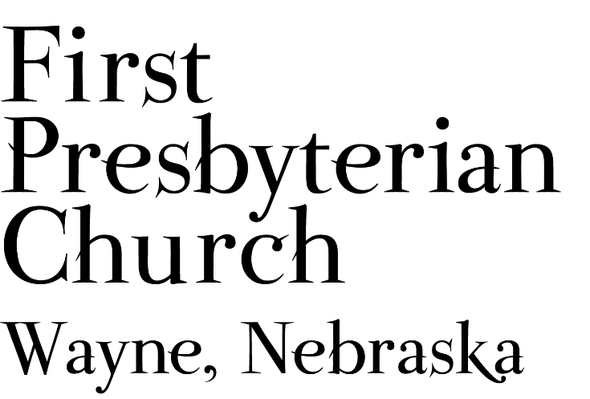
If you are a guest, we invite you to return and worship with us often. If you don't have a church home, please consider our church family your church family.

FPC CHURCH WEEK
Sunday 10:00am Worship with Communion
11:00am Sundae Sunday
7:00pm WSC Athletes Packing Backpacks
Monday 9:30am Wayne Family Coalition Meeting
Tuesday morning Pastor at Lions Eye Screening at WCS
Thursday 10:00am Salvation Army Meeting at FPC

PRAYER CONCERNS
Hold in Prayer: Prayers for healing for Bev Beeson, Diane Confer (sister-in-law to Pastor Teresa) Glen Confer, Joseph Woerdemann and Eric Liska (he has finished treatments). The family of Rosemary Brodersen, sister-in-law to Karen Johnson, who died suddenly. Remember Shea Abraham and all our service personnel serving around the world. All those impacted by the earthquake and storms in Haiti, the impacts of Hurricane Ida, the fires in our country and all those working in response to these disasters. All those who have been displaced due to the natural disasters. All our students, teachers, administrators & parents at all levels as school resumes.

ANNOUNCEMENTS
  - Sundae Sunday - Join us after worship today as we begin the new church year. We’ll gather for ice cream and toppings during Fellowship time.
- We need lawn mowing volunteers for September. You can sign-up on-line, in Fellowship Hall on the Opportunity Table or contact the office. Thank you to all who have been mowing the church lawn.
- Coffee Fellowship will resume next Sunday, and we will need fellowship hosts to prepare refreshments. Please sign up in Fellowship Hall or contact Jenny. September 19th and 26th hosts are needed.
- Jim Curtiss has moved to Omaha. Ask at the office if you would like his new address.
- Grace Lutheran is hosting a free Country and Gospel Music Concert at the Willow Bowl today from 5pm to 7pm. It is a FREE concert by Jake Gill. He was a contestant on The Voice, and many other contests and has performed with Jason Aldean and other country stars. Free donation will help cover expenses and help fund participants for the upcoming National Youth Gathering.
- POTENTIAL BIBLE STUDY: As plans are being made for the upcoming church year 2021-2022. Pastor Teresa would like to know if there is an interest in the congregation for a monthly Bible Study. If so what day/evening of the week and what time would work into your schedule?
- FPC is currently operating with mask-optional protocol. This does not mean there is no need for caution rather that each individual or family can make their own determination regarding the wearing of masks based on their health and comfort level. Hand sanitizer and masks continue to be available. The access to Zoom will continue for those who desire to worship in that manner. The Session and Pastor Teresa thank everyone for their co-operation.

FPC Service Recordings can be found at:
*Facebook @ First Presbyterian Church – Wayne, Nebraska
*Our website @ fpcwayne.com
*YouTube @ FPC of Wayne Nebraska
FPC Online Worship Bulletins can be found at:
https://fpcwayne.com/fpc-wayne-worship-bulletins/

