

September 19, 2021 + 10:00am

Welcome to First Presbyterian,
whether this is your first visit, or you are a regular worshiper,
we are happy you are here. Together let us praise our Triune God.

THE GATHERING

WELCOME
This is the day the Lord has made,
Let us rejoice and be glad in it, Alleluia!!

PRAYERS & PRAISES

+ PASSING THE PEACE

PRELUDE

+CALL TO WORSHIP
Listen to the good news; God is with us, this day and every day.
Because God is with us, we can face each day with courage.
We can find some good in everything, for we are never completely alone.
God’s goodness sometimes seems to be a trickle, sometimes pulsing spurts,
and sometimes a mighty flood, but always God is with us.
We worship you, O God, for your goodness.
We praise you with our songs we seek you in our prayers.
We offer ourselves to you because you are our God.
Alleluia, Amen.

+ PRAYER OF ADORATION

+ HYMN OF PRAISE “Joyful, Joyful We Adore Thee” #464

CALL TO CONFESSION

UNISON PRAYER OF CONFESSION
Almighty God, we confess how hard it is to be your people. You have called us to be the church, to continue the mission of Jesus Christ to our lonely and confused world. Yet we acknowledge we are more apathetic than active, isolated than involved, callous than compassionate, obstinate than obedient, legalistic than loving. Gracious Lord, have mercy upon us and forgive our sins. Remove the obstacles preventing us from being your representatives to a broken world. Awaken our hearts to the promised gift of your indwelling Spirit. This we pray in Jesus’ powerful name. Amen.

SILENT PRAYER OF CONFESSION

ASSURANCE OF PARDON
+ RESPONSE “Alleluia, Alleluia! Give Thanks” #106
(Refrain 2X)
Refrain: Alleluia, alleluia! Give thanks to the risen Lord.
Alleluia, alleluia! Give Praise to His Name.

THE WORD

PRAYER FOR ILLUMINATION

SCRIPTURE READINGS
OLD TESTAMENT: Isaiah 43:15-21
NEW TESTAMENT: Acts 11:1-18

This is the Word of the Lord
Thanks be to God.

SERMON “Canoeing the Mountains”

HYMN OF RESPONSE “Let Us Build a House/All Are Welcome”
(on back cover)

THE THANKSGIVING

PRAYERS OF THE PEOPLE

THE LORD’S PRAYER
Our Father, who art in heaven, hallowed be thy name. Thy kingdom come, thy will be done, on earth as it is in heaven. Give us this day our daily bread; and forgive us our debts, as we forgive our debtors; and lead us not into temptation but deliver us from evil. For thine is the kingdom, and the power, and the glory forever. Amen.

CALL TO OFFERING

OFFERTORY
Please place your offering
in the box on the table at the rear of the sanctuary.

+ DOXOLOGY “Glory Be to the Father” #579
Glory to the Father, and to the Son, and to the Holy Ghost;
As it was in the beginning, is now, and ever will be,
world without end. Amen. Amen.

+ PRAYER OF DEDICATION
God, receive these gifts and give us open hands.
Fill our lives and give us open hearts.
Touch us with prophecy and give us open minds.
Bless this church, by the Spirit open our doors
welcoming friends and strangers alike. Amen.

THE SENDING

+ SENDING HYMN “God of Grace and God of Glory” #420

+ BENEDICTION

+ CONGREGATIONAL RESPONSE “Song of Hope ” #432
May the God of hope go with us ev'ry day,
Filling all our lives with love and joy and peace.
May the God of justice speed us on our way,
Bringing light and hope to ev'ry land and race.

Refrain:
Praying, let us work for peace,
Singing, share our joy with all,
Working for a world that's new,
Faithful when we hear Christ's call.

+ POSTLUDE

+ Please stand if you are able and comfortable.

Music - Permission to print hymn text, podcast/stream the music in this service obtained from ONE LICENSE with license #A-727318. All rights reserved. Some music is in the public domain.

PARTICIPATING IN THE SERVICE
Pastor The Rev. Teresa Bartlett
Lector/Greeter Candyce Peitz
Accompanist Sarah Wibben



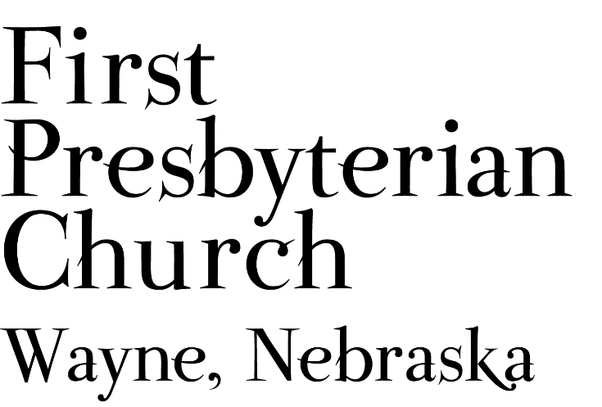
If you are a guest, we invite you to return and worship with us often. If you don't have a church home, please consider our church family your church family.

FPC CHURCH WEEK
Sunday 10:00am Worship
11:00am Fellowship
1:30pm Pastor leads chapel at Countryview
4:00pm Cub Scouts in Fellowship Hall

PRAYER CONCERNS
Continued prayers for healing for Bev B. currently recovering at Madonna Rehabilitation Hospital in Omaha, Diane C. (sister-in-law to Pastor Teresa), Glen C., (Pastor Teresa’s father, currently in skilled care). Joseph W. has begun his treatments. Eric L. has completed his course of treatment and will continue regular check-ups. Remember Shea A. and all our service personnel. Those impacted or displaced by hurricane Ida, those grieving loved ones and property. Those who experienced flash floods, fires and other storms and the volunteers and workers who have responded to assist the people in need. All our students, teachers, administrators & parents at all levels as school continues.

ANNOUNCEMENTS
- We need lawn mowing volunteers for September. You can sign-up on-line, in Fellowship Hall on the Opportunity Table or contact the office. Thank you to all who have been mowing the church lawn.
- Coffee Fellowship has resumed, and we need fellowship hosts to prepare refreshments. Please sign up in Fellowship Hall or contact Jenny. September 26th hosts are needed. Please consider sharing the gift of hospitality.
- Greeters & lectors are needed. Please volunteer or say “yes” when asked.
- Jim C. has moved to Omaha. Ask at the office if you would like his new address.
- FPC is currently operating with mask-optional protocol. This does not mean there is no need for caution rather that each individual or family can make their own determination regarding the wearing of masks based on their health and comfort level. Hand sanitizer and masks continue to be available. The access to Zoom will continue for those who desire to worship in that manner. The Session and Pastor Teresa thank everyone for their co-operation.

FPC Service Recordings can be found at:
*Facebook @ First Presbyterian Church – Wayne, Nebraska
*Our website @ fpcwayne.com
*YouTube @ FPC of Wayne Nebraska
FPC Online Worship Bulletins can be found at:
https://fpcwayne.com/fpc-wayne-worship-bulletins/

