

September 26, 2021 + 10:00am

Welcome to First Presbyterian,
whether this is your first visit, or you are a regular worshiper,
we are happy you are here. Together let us praise our Triune God.

THE GATHERING

WELCOME
This is the day the Lord has made,
Let us rejoice and be glad in it, Alleluia!!

PRAYERS & PRAISES

+ PASSING THE PEACE

PRELUDE

+ CALL TO WORSHIP
If you are weak and in need of strength,
if you are feeling fragile, or vulnerable,
know that you are welcome here,
know that Christ beckons you here,
know that you are loved here.
We come to worship like children, ready to rest in God’s arms.

+ PRAYER OF ADORATION

+ HYMN OF PRAISE “Praise Ye the Lord, the Almighty” #482

CALL TO CONFESSION

UNISON PRAYER OF CONFESSION (Written by Beth Merrill Neel)
Holy God, Creator of all that is, Donor of Grace, and Giver of Life:
Hear our prayer. There are chasms in our lives, deep valleys that separate us from one another and from You. We confess that we have allowed those rifts to grow, for fear of admitting our part in the separation, For fear of being rejected when we reach out. You call us to a reconciled life, to healed relationships, to a wholeness with each other and with You.
Mend us, we pray, and make us new creations through the power and love of Christ, in whose name we pray. Amen.

SILENT PRAYER OF CONFESSION

ASSURANCE OF PARDON

+ RESPONSE “Alleluia, Alleluia! Give Thanks” #106
(Refrain 2X)
Refrain: Alleluia, alleluia! Give thanks to the risen Lord.
Alleluia, alleluia! Give Praise to His Name.

THE WORD

PRAYER FOR ILLUMINATION

SCRIPTURE READINGS
OLD TESTAMENT: Isaiah 55:6-13
NEW TESTAMENT: Romans 14:1-13

This is the Word of the Lord
Thanks be to God.

SERMON “Sixes & Nines”

HYMN OF RESPONSE “Lord, Make Us Servants of Your Peace” #374

THE THANKSGIVING

PRAYERS OF THE PEOPLE

THE LORD’S PRAYER
Our Father, who art in heaven, hallowed be thy name. Thy kingdom come, thy will be done, on earth as it is in heaven. Give us this day our daily bread; and forgive us our debts, as we forgive our debtors; and lead us not into temptation but deliver us from evil. For thine is the kingdom, and the power, and the glory forever. Amen.

CALL TO OFFERING

OFFERTORY
Please place your offering
in the box on the table at the rear of the sanctuary.

+ DOXOLOGY “Glory Be to the Father” #579
Glory to the Father, and to the Son, and to the Holy Ghost;
As it was in the beginning, is now, and ever will be,
world without end. Amen. Amen.

+ RESPONSIVE PRAYER OF DEDICATION
God, receive these gifts and give us open hands.
Fill our lives and give us open hearts.
Touch us with prophecy and give us open minds.
Bless this church, by the Spirit open our doors
welcoming friends and strangers alike. Amen.

THE SENDING

+ SENDING HYMN “When We Are Living” #400

+ BENEDICTION

+ CONGREGATIONAL RESPONSE “Song of Hope” #432
May the God of hope go with us ev'ry day,
Filling all our lives with love and joy and peace.
May the God of justice speed us on our way,
Bringing light and hope to ev'ry land and race.

Refrain:
Praying, let us work for peace,
Singing, share our joy with all,
Working for a world that's new,
Faithful when we hear Christ's call.

+ POSTLUDE

+ Please stand if you are able and comfortable.

Music - Permission to print hymn text, podcast/stream the music in this service obtained from ONE LICENSE with license #A-727318. All rights reserved. Some music is in the public domain.

PARTICIPATING IN THE SERVICE
Pastor The Rev. Teresa Bartlett
Lector Mark Hammer
Accompanist Jane O’Leary
Greeter Jenny Hammer
Fellowship Hosts Anita & John Fuelberth



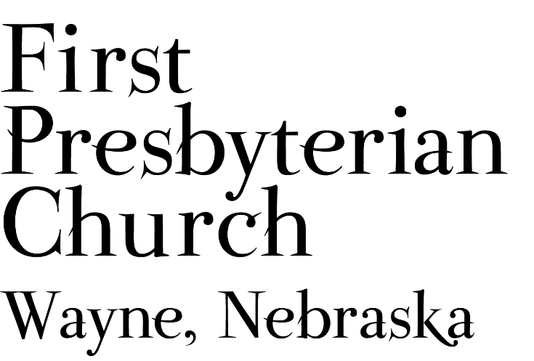
If you are a guest, we invite you to return and worship with us often. If you don't have a church home, please consider our church family your church family.

FPC CHURCH WEEK
Sunday 10:00am Worship
11:00am Fellowship
4:00pm Cub Scouts in Fellowship Hall

PRAYER CONCERNS
Continued prayers for healing for Bev Beeson currently recovering at Madonna Rehabilitation Hospital in Omaha, Diane Confer (sister-in-law to Pastor Teresa), Glen Confer, (Pastor Teresa’s father, currently in skilled care). Joseph Woerdemann has begun his treatments. Eric Liska has completed his course of treatment and will continue regular check-ups. Remember Shea Abraham and all our service personnel. Those impacted or displaced by hurricane Ida, those grieving loved ones and property. Those who experienced flash floods, fires and other storms and the volunteers and workers who have responded to assist the people in need. All our students, teachers, administrators & parents at all levels as school continues. Pray for the farmers as the harvest season has begun.

ANNOUNCEMENTS
- Norman Jepsen from the Gideon’s is here to tell us about the work of the Gideon’s. There will be a free-will offering to support the work of the Gideon’s following worship. Welcome Norman.
- World Communion Sunday will be held October 3rd during worship. Join us as we share the Bread of Life and the Cup of Salvation alongside Christians in all different traditions around the world. The communion elder will be Shari Dunklau.
- The Deacons are planning for a special Coat Closet event, Saturday, October 9th. We will need some extra hands to reconfigure Fellowship Hall after worship on October 3 to prepare for set-up on October 6th. We will be moving coats from downstairs into Fellowship Hall for the Coat give away. If you can help please contact Pastor Teresa or Karen Johnson.
- We need lawn mowing volunteers for the rest of September and all of October. You can sign-up on-line, in Fellowship Hall on the Opportunity Table or contact the office. Thank you to all who have been mowing the church lawn.
- Coffee Fellowship has resumed, and we need fellowship hosts to prepare refreshments. Please sign up in Fellowship Hall or contact Jenny. Please consider sharing the gift of hospitality.
- Greeters & lectors are needed. Please volunteer or say “yes” when asked.
- FPC is currently operating with mask-optional protocol. This does not mean there is no need for caution rather that each individual or family can make their own determination regarding the wearing of masks based on their health and comfort level. Hand sanitizer and masks continue to be available. The access to Zoom will continue for those who desire to worship in that manner. The Session and Pastor Teresa thank everyone for their co-operation.

FPC Service Recordings can be found at:
*Facebook @ First Presbyterian Church – Wayne, Nebraska
*Our website @ fpcwayne.com
*YouTube @ FPC of Wayne Nebraska
FPC Online Worship Bulletins can be found at:
https://fpcwayne.com/fpc-wayne-worship-bulletins/



