

October 3, 2021 + 10:00am

Welcome to First Presbyterian,
whether this is your first visit, or you are a regular worshiper,
we are happy you are here. Together let us praise our Triune God.

THE GATHERING

WELCOME
All God’s beloved children, young and old,
from east and west, north and south,
are welcome in this place.
We gather to celebrate God’s love and grace
and our unity in Christ.
Let us praise God together.

PRAYERS & PRAISES
+ PASSING THE PEACE

PRELUDE “Come All You People”
(Zimbabwe)

+ CALL TO WORSHIP
Christians near and far gather today around God's table,
We are the People of God!
Though we differ in language, custom, and tradition,
We are brothers and sisters in Christ!
For there is one Lord, one faith, and one baptism,
We are One in God's Spirit!
We are one, and together we remember our Lord Jesus,
For we are the people of Redemption!
He gave himself up for us, so we could be reconciled to God.
Come, let us worship the God of our Salvation!

+ PRAYER OF ADORATION

+ HYMN OF PRAISE “Come All You People” (2x)
“All Are Welcome” (verses 1, 3, 5) Insert
(Zimbabwe)

CALL TO CONFESSION

UNISON PRAYER OF CONFESSION
God of compassion and mercy, we are your wounded and wounding children. We bring before you our wounded selves, our divided society, and our broken world, seeking your healing and transforming grace. It is easy for us to point the finger at others, yet we know that we all need your forgiveness; in your presence today we lift up not only the victims of conflicts, but also those we have called enemies. Break down the walls of hatred, distrust and bitterness and open a way for us to reach one another in truth and love. Enable us to build a society where all can belong; to share our gifts in mutual respect and to seek for the new future which you offer us.

SILENT PRAYER OF CONFESSION

ASSURANCE OF PARDON

+ RESPONSE “Alleluia, Alleluia! Give Thanks” #106
(Refrain 2X)
Refrain: Alleluia, alleluia! Give thanks to the risen Lord.
Alleluia, alleluia! Give Praise to His Name.

THE WORD

PRAYER FOR ILLUMINATION

SCRIPTURE READINGS
OLD TESTAMENT: Psalm 96
NEW TESTAMENT: Romans 12:3-21

This is the Word of the Lord
Thanks be to God.

SERMON

HYMN OF RESPONSE “Jesu, Jesu, Fill Us with Your Love” #367
(Ghanaian)

THE THANKSGIVING

CALL TO OFFERING

OFFERTORY
Please place your offering
in the box on the table at the rear of the sanctuary.

+ DOXOLOGY “Glory Be to the Father” #579
Glory to the Father, and to the Son, and to the Holy Ghost;
As it was in the beginning, is now, and ever will be,
world without end. Amen. Amen.

+ PRAYER OF DEDICATION

INVITATION TO THE LORD’S TABLE

COMMUNION HYMN “Let Us Talents and Tongues Employ” #514
(Jamaican Folk Melody)

PRAYER OF THANKSGIVING
The Lord be with you,
And also, with you.
Lift up your hearts.
We lift them up to the Lord.
Let us give thanks to the Lord our God.
It is right for us to give thanks and praise
O living God, for your blessing in creation, for your image deep within us, for your life in all its fullness,
We give thanks.

PRAYERS OF CONCERN AND BLESSING

THE LORD’S PRAYER
Our Father, who art in heaven, hallowed be thy name. Thy kingdom come, thy will be done, on earth as it is in heaven. Give us this day our daily bread; and forgive us our debts, as we forgive our debtors; and lead us not into temptation, but deliver us from evil. For thine are the kingdom, and the power, and the glory forever. Amen.

DISTRIBUTION OF ELEMENTS
Please come forward by the northwest aisle to receive the cup of bread and juice and return to your seat.

WORDS OF INSTIUTION

UNISON PRAYER OF THANKSGIVING
Gracious God, you have made us one with all your people in heaven and on earth. You have fed us with the bread of life and renewed us for our service. God of peace, may this meal, shared in the Spirit with your son Jesus, strengthen us to act justly, to love mercy and walk humbly with our Triune God. Amen.

THE SENDING

+ SENDING HYMN "We Are Marching in the Light of God” (2x)
(Siyahamba) Insert

+ BENEDICTION

+ CONGREGATIONAL RESPONSE “Song of Hope” #432
May the God of hope go with us ev'ry day,
Filling all our lives with love and joy and peace.
May the God of justice speed us on our way,
Bringing light and hope to ev'ry land and race.

Refrain:
Praying, let us work for peace,
Singing, share our joy with all,
Working for a world that's new,
Faithful when we hear Christ's call.

+ POSTLUDE

+ Please stand if you are able and comfortable.

Music - Permission to print hymn text, podcast/stream the music in this service obtained from ONE LICENSE with license #A-727318. All rights reserved. Some music is in the public domain.

PARTICIPATING IN THE SERVICE
Pastor The Rev. Teresa Bartlett
Lector & Greeters Kent & Jodi Pulfer
Accompanist Jane O’Leary



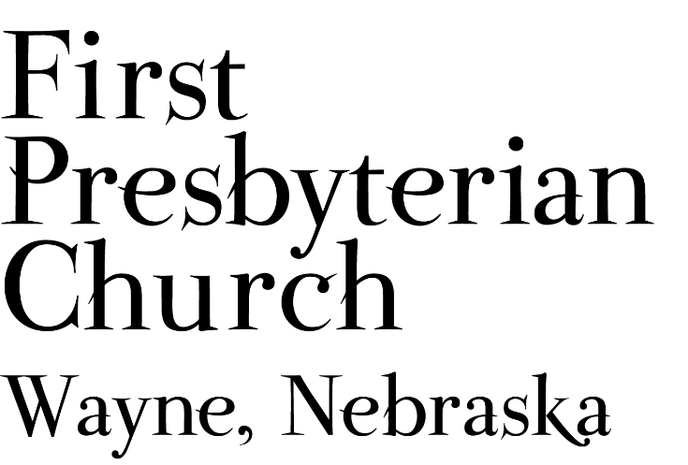
If you are a guest, we invite you to return and worship with us often. If you don't have a church home, please consider our church family your church family.
FPC CHURCH WEEK
Sunday 10:00am Worship
11:00am Fellowship
4:00pm Cub Scouts in Fellowship Hall
Wednesday 3:30pm Chapel at Kinship Pointe
4:30pm Set-up for Coat Event
Saturday 10:00am-2:00pm Coat Closet Giveaway

PRAYER CONCERNS
Continued prayers for healing for Bev Beeson, Diane Confer (sister-in-law to Pastor Teresa), Glen Confer (Pastor Teresa’s father, currently in skilled care). Joseph Woerdemann has begun his treatments. Eric Liska has completed his course of treatment and will continue regular check-ups. Remember Shea Abraham and all our service personnel. Those who experienced flash floods, fires and other storms and the volunteers and workers who have responded to assist the people in need. All our students, teachers, administrators & parents at all levels as school continues during the Covid crisis. Pray for the farmers as the harvest season has begun.

ANNOUNCEMENTS
- World Communion Sunday: Join us this morning as we share the Bread of Life and the Cup of Salvation alongside Christians in all different traditions around the world. The communion elder will be John Fuelberth.
- The Deacons are planning for a Coat Give-away event, Saturday, October 9th. We will need some extra hands to reconfigure Fellowship Hall today after worship to prepare for set-up on October 6th. On Wednesday we will be moving coats from downstairs into Fellowship Hall for the Coat give away. If you can help please contact Pastor Teresa or Karen Johnson.
- Fall Decorating: If you would like to provide pumpkins, gourds or other fall decorations (artificial or real) to use in decorating the sanctuary, please bring those items to church by October 7th and leave them in Fellowship Hall or with Pastor Teresa.
- We need lawn mowing volunteers for October. You can sign-up on-line, in Fellowship Hall on the Opportunity Table or contact the office. Thank you to all who have been mowing the church lawn.
- Coffee Fellowship has resumed, and we need fellowship hosts to prepare refreshments. Please sign up in Fellowship Hall or contact Jenny. Please consider sharing the gift of hospitality.
- Greeters & lectors are needed. Please volunteer or say “yes” when asked.
- FPC is currently operating with mask-optional protocol. This does not mean there is no need for caution rather that each individual or family can make their own determination regarding the wearing of masks based on their health and comfort level. Hand sanitizer and masks continue to be available. The access to Zoom will continue for those who desire to worship in that manner. The Session and Pastor Teresa thank everyone for their co-operation.

FPC Service Recordings can be found at:
*Facebook @ First Presbyterian Church – Wayne, Nebraska
*Our website @ fpcwayne.com
*YouTube @ FPC of Wayne Nebraska
FPC Online Worship Bulletins can be found at:
https://fpcwayne.com/fpc-wayne-worship-bulletins/

