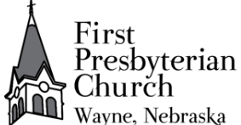
'June 28, 2026 + 10:00am
Welcome to First Presbyterian, whether this is your first visit, or you are a regular worshiper, we are happy you are here. Together let us praise our Triune God.
THE GATHERING
PRAYER & MEDITATION
“For the Spirit God gave us does not make us timid, but gives us power,
love and self-discipline.” 2 Timothy 1:7 NIV
GATHERING MUSIC
WELCOME
PRAYERS AND PRAISES
ANNOUNCEMENTS
+ PASSING THE PEACE OF CHRIST
PRELUDE
RESPONSIVE CALL TO WORSHIP:
We are called to bring a new understanding of God: that God so loves the world.
We are the salt of the earth.
We are called to bring a new hope in God: that God gives us new life.
We are the light of the world.
We are called to follow the commandments and the law.
The Law of God is to love God
and to love one another.
Come, let us be the salt of the earth, the light of the world.
Come, let us love one another with the love of God.
Let us join together in our love of God to worship and follow Jesus.
PRAYER OF ADORATION
+ HYMN “Joyful, Joyful, We Adore Thee” #464

CALL TO CONFESSION
UNISON PRAYER OF CONFESSION
Lord, we confess that we sometimes prefer the darkness to your light. We turn away, we hide, we seek our own way. Forgive us Lord, renew in us a desire to walk in your light and to reflect your light to those around us. By the mercy of your Son, Christ be our light, dispel the darkness. Shine in our hearts, shine in your church, we may be children of light. In Jesus’ name, Amen.
TIME OF SILENT CONFESSION
RESPONSIVE ASSURANCE OF PARDON
Friends believe the good news of the Gospel:
In Christ, you are forgiven. In Christ, you are renewed. In Christ, you are made whole.
Thanks be to God! Amen.
+ RESPONSE “Gloria Patria” #579
Glory be to the Father, and to the Son, and to the Holy Ghost.
As it was in the beginning, it is now, and ever shall be,
world without end. Amen, Amen
THE WORD
PRAYER FOR ILLUMINATION
SCRIPTURE READING
OLD TESTAMENT READING – Isaiah 9:2-11 (NIV) p 1073
NEW TESTAMENT READING – Matthew 5:13-16 (NIV) p 1505
This is the Word of the Lord
Thanks be to God.
MEDITATION “Go Light the World”
+HYMN OF RESPONSE “This Little Light of Mine” Insert

THE THANKSGIVING
PRAYERS OF THE PEOPLE
THE LORD’S PRAYER
Our Father, who art in heaven, hallowed be thy name. Thy kingdom come, thy will be done, on earth as it is in heaven. Give us this day our daily bread; and forgive us our debts, as we forgive our debtors; and lead us not into temptation but deliver us from evil. For thine is the kingdom, and the power, and the glory forever. Amen.
CALL TO OFFERING
Please place your offering in the box on the table at the rear of the sanctuary.
+ DOXOLOGY Old Hundredth (alternate words by Isaac Watts)
Were the whole realm of nature mine that were a present far too small; love so amazing, so divine demands my soul, my life, my all.

+ UNISON PRAYER OF DEDICATION
Almighty God, receive these gifts for your service.
Fill our lives- give us open hearts- open our hands.
Touch us with prophecy – give us open minds.
Bless this church, that we may be a blessing to others. Amen.
THE SENDING
+ SENDING HYMN “Go to the World” Insert
+BENEDICTION
+ CONGREGATIONAL RESPONSE “Song of Hope” #432
May the God of hope go with us every day,
filling all our lives with love and joy and peace.
May the God of justice speed us on our way,
bringing light and hope to every land and race.
Praying, let us work for peace; singing, share our joy with all;
working for a world that's new,
faithful when we hear Christ's call.
+ POSTLUDE
+ Please stand if you are able and comfortable.
Music – Permission to print hymn text, podcast/stream the music in this service obtained from ONE LICENSE with license #A-727318. All rights reserved. Some music is in the public domain.
If you are a guest, we invite you to return and worship with us often. If you don't have a church home, please consider our church family your church family. Guests are encouraged to complete the yellow guest card in your pew and place it in the offering box or give it to the greeter or pastor
PARTICIPATING IN THE SERVICE
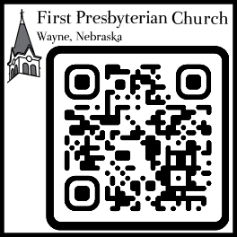
Pastor Rev. Teresa Bartlett
Lector/Greeter Candyce Peitz
Accompanist Nora Armstrong
FPC CHURCH WEEK – June 14, 2026
Sunday 10:00am Worship
11:00am Fellowship
1:30pm Country View Chapel
Mon-Fri 5:40am KTCH Devotions
Tuesday 1:15pm Kinship Bible Study
PRAYERS & PRAISES
- Pray for Jenny Hammer, Milton & Jackie Owens, Carol Mosley, Joan Lage, Brenda Beeson, Shari Paige, Susan Cunnigham, niece of Bev Beeson, facing cancer,
- Pray for all who are confined to their homes due to illness.
- Remember our brothers and sisters worldwide in need of clean water, food, and safe shelter.
- Remember those who grieve.
- Pray for peace in our country and around the world.
FPC ANNOUNCEMENTS
- Session meeting has been moved to June 29th at 7:00 p.m.
- Bible study continues at Kinship Pointe at 1:15 p.m. on Tuesday afternoons.
- For July you are asked to donate complete pancake mix for the Wayne Food Pantry.
- The final worship service at Bancroft Presbyterian Church will be today, June 28th at 1:30 p.m. All are welcome to attend the service and reception following the service.
- Lectors & Greeters are needed-please volunteer or say yes

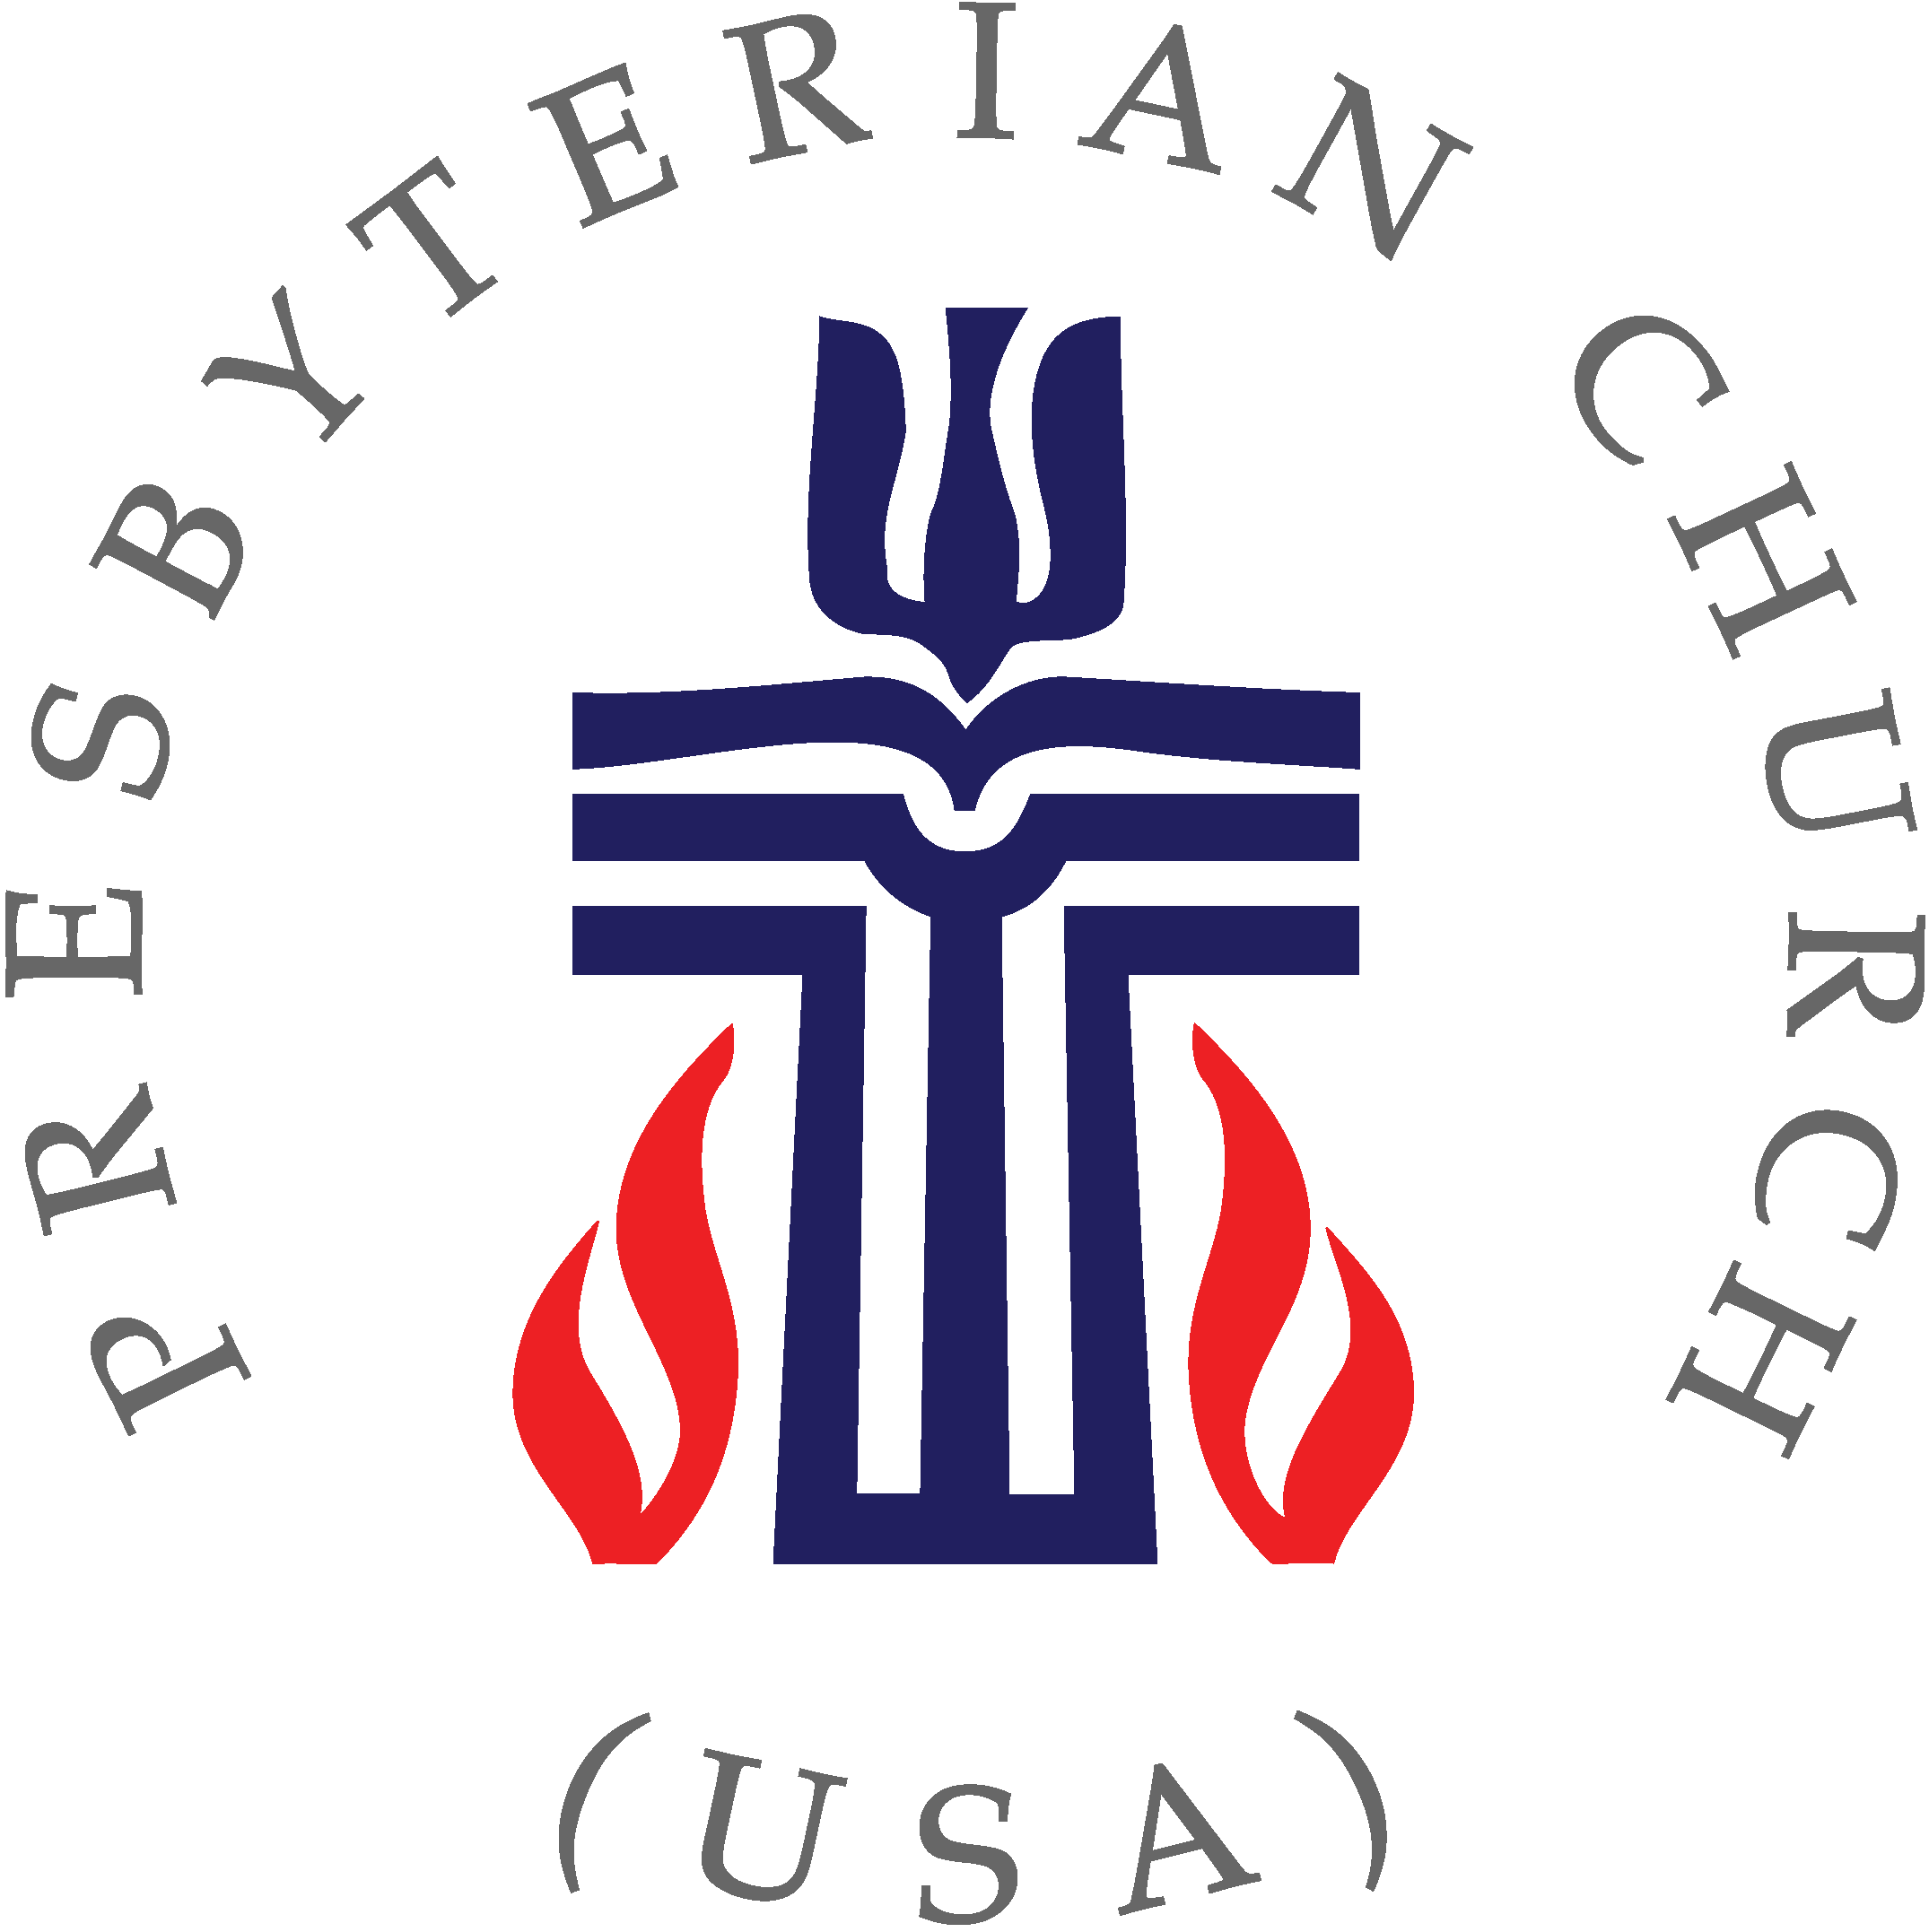

fpcwayne.com + fpcwayne@gmail.com + 402-375-2669
find us on Facebook at First Presbyterian Church - Wayne, Nebraska

