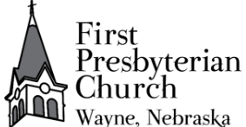
July 5, 2026 + 10:00am
Welcome to First Presbyterian, whether this is your first visit, or you are a regular worshiper, we are happy you are here. Together let us praise our Triune God.
THE GATHERING
GATHERING MUSIC
WELCOME
PRAYERS AND PRAISES
ANNOUNCEMENTS
+ PASSING THE PEACE OF CHRIST
PRELUDE - Congregational Singing
“Come Into God’s Presence” #413
Come into God’s presence singing
“Alleluia, alleluia, alleluia.”
Come into God’s presence singing
“Jesus is Lord, Jesus is Lord, Jesus is Lord.”
Praise the Lord together singing
“Worthy the Lamb, worthy the Lamb, worthy the Lamb.”
Praise the Lord together singing
“Glory to God, glory to God, glory to God.”
RESPONSIVE CALL TO WORSHIP: Based on Psalm 145
O Lord, you are gracious and merciful,
slow to anger and abounding in steadfast love.
You are good to all people,
with compassion for all of your creation.
All your works give thanks to you, O Lord,
and all your faithful people bless you.
They speak of the glory of your realm
and tell of your wondrous deeds.
You are faithful in your words, O Lord,
and gracious in all your deeds.
Let us worship God.
PRAYER OF ADORATION
+HYMN – “Spirit Divine, Attend Our Prayers” #325 Verses 1,3,5.
CALL TO CONFESSION
UNISON PRAYER OF CONFESSION
Most gracious and merciful God, we confess to you and to each other that time after time we have entered your presence with countless prayers but with hearts that have been closed to your grace. We have lifted our hands in praise, but our feet have still walked in the ways of evil . We have refused to see your face in the needs of our neighbor. We pray Lord that you forgive our lack of faith, pardon our acts of injustice as we ask for forgiveness from those we have harmed. May we move forward guided by your all powerful Word and the Holy Spirit. We pray in the name Jesus Christ, our Lord. Amen.
TIME OF SILENT CONFESSION
RESPONSIVE ASSURANCE OF PARDON
Friends believe the good news of the Gospel:
In Christ, you are forgiven. In Christ, you are renewed. In Christ, you are made whole.
Thanks be to God! Amen.

+ RESPONSE “Gloria Patria” #579
Glory be to the Father, and to the Son, and to the Holy Ghost.
As it was in the beginning, it is now, and ever shall be,
world without end. Amen, Amen
THE WORD
PRAYER FOR ILLUMINATION
SCRIPTURE READING
OLD TESTAMENT READING – Psalm 145:8-13 (NIV) p 979
NEW TESTAMENT READING – Romans 7:14-25 (NIV) p 1753
This is the Word of the Lord
Thanks be to God.
MEDITATION
+HYMN OF RESPONSE – “Hope of the World” #360 v.1, 2,4
THE THANKSGIVING
PRAYERS OF THE PEOPLE
THE LORD’S PRAYER
Our Father, who art in heaven, hallowed be thy name. Thy kingdom come, thy will be done, on earth as it is in heaven. Give us this day our daily bread; and forgive us our debts, as we forgive our debtors; and lead us not into temptation but deliver us from evil. For thine is the kingdom, and the power, and the glory forever. Amen.
CALL TO OFFERING
Please place your offering in the box on the table at the rear of the sanctuary.

+DOXOLOGY-“Praise God, from Whom All Blessings Flow” #591
Praise God, from whom all blessings flow.
Praise Christ, all people here below.
Praise Holy Spirit evermore.
Praise Triune God, whom we adore. Amen.

+ UNISON PRAYER OF DEDICATION
Almighty God, receive these gifts for your service.
Fill our lives- give us open hearts- open our hands.
Touch us with prophecy – give us open minds.
Bless this church, that we may be a blessing to others. Amen.
THE SENDING
+ SENDING HYMN “O Beautiful for Spacious Skies” #564
+BENEDICTION
+ CONGREGATIONAL RESPONSE “Song of Hope” #432
May the God of hope go with us every day,
filling all our lives with love and joy and peace.
May the God of justice speed us on our way,
bringing light and hope to every land and race.
Praying, let us work for peace; singing, share our joy with all;
working for a world that's new,
faithful when we hear Christ's call.
+ POSTLUDE
+ Please stand if you are able and comfortable.
Music – Permission to print hymn text, podcast/stream the music in this service obtained from ONE LICENSE with license #A-727318. All rights reserved. Some music is in the public domain.
If you are a guest, we invite you to return and worship with us often. If you don't have a church home, please consider our church family your church family. Guests are encouraged to complete the yellow guest card in your pew and place it in the offering box or give it to the greeter or pastor
PARTICIPATING IN THE SERVICE
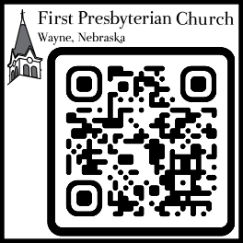
Pastor Rev. Teresa Bartlett
Lector/Greeter Ronda Ras
Accompanist Nora Armstrong
FPC CHURCH WEEK – June 14, 2026
Sunday 10:00am Worship
11:00am Fellowship
Tuesday 1:15pm Kinship Bible Study
PRAYERS & PRAISES
- Continue to pray for Jenny Hammer, Milton & Jackie Owens, Carol Mosley, Joan Lage, Brenda Beeson, Shari Paige, Susan Cunnigham, niece of Bev Beeson, facing cancer.
- Pray for all who are confined to their homes due to illness.
- Remember our brothers and sisters worldwide in need of clean water, food, and safe shelter.
- Pray for Venezuela and all recovering from natural disasters.
- Remember those who grieve.
- Pray for peace in our country and around the world.
FPC ANNOUNCEMENTS
- Coffee House worship is July 20th, fellowship host & discussion leader needed.
- Bible study continues at Kinship Pointe at 1:15 p.m. on Tuesday afternoons.
- Request for volunteers – Someone to take paper recycling to the Transfer Station monthly or more often as desired. Someone to sort photos and insert into a photo album and label with names if possible.
- For July you are asked to donate pancake mix for the Food Pantry.
- Lectors & Greeters are needed-please volunteer or say yes when asked
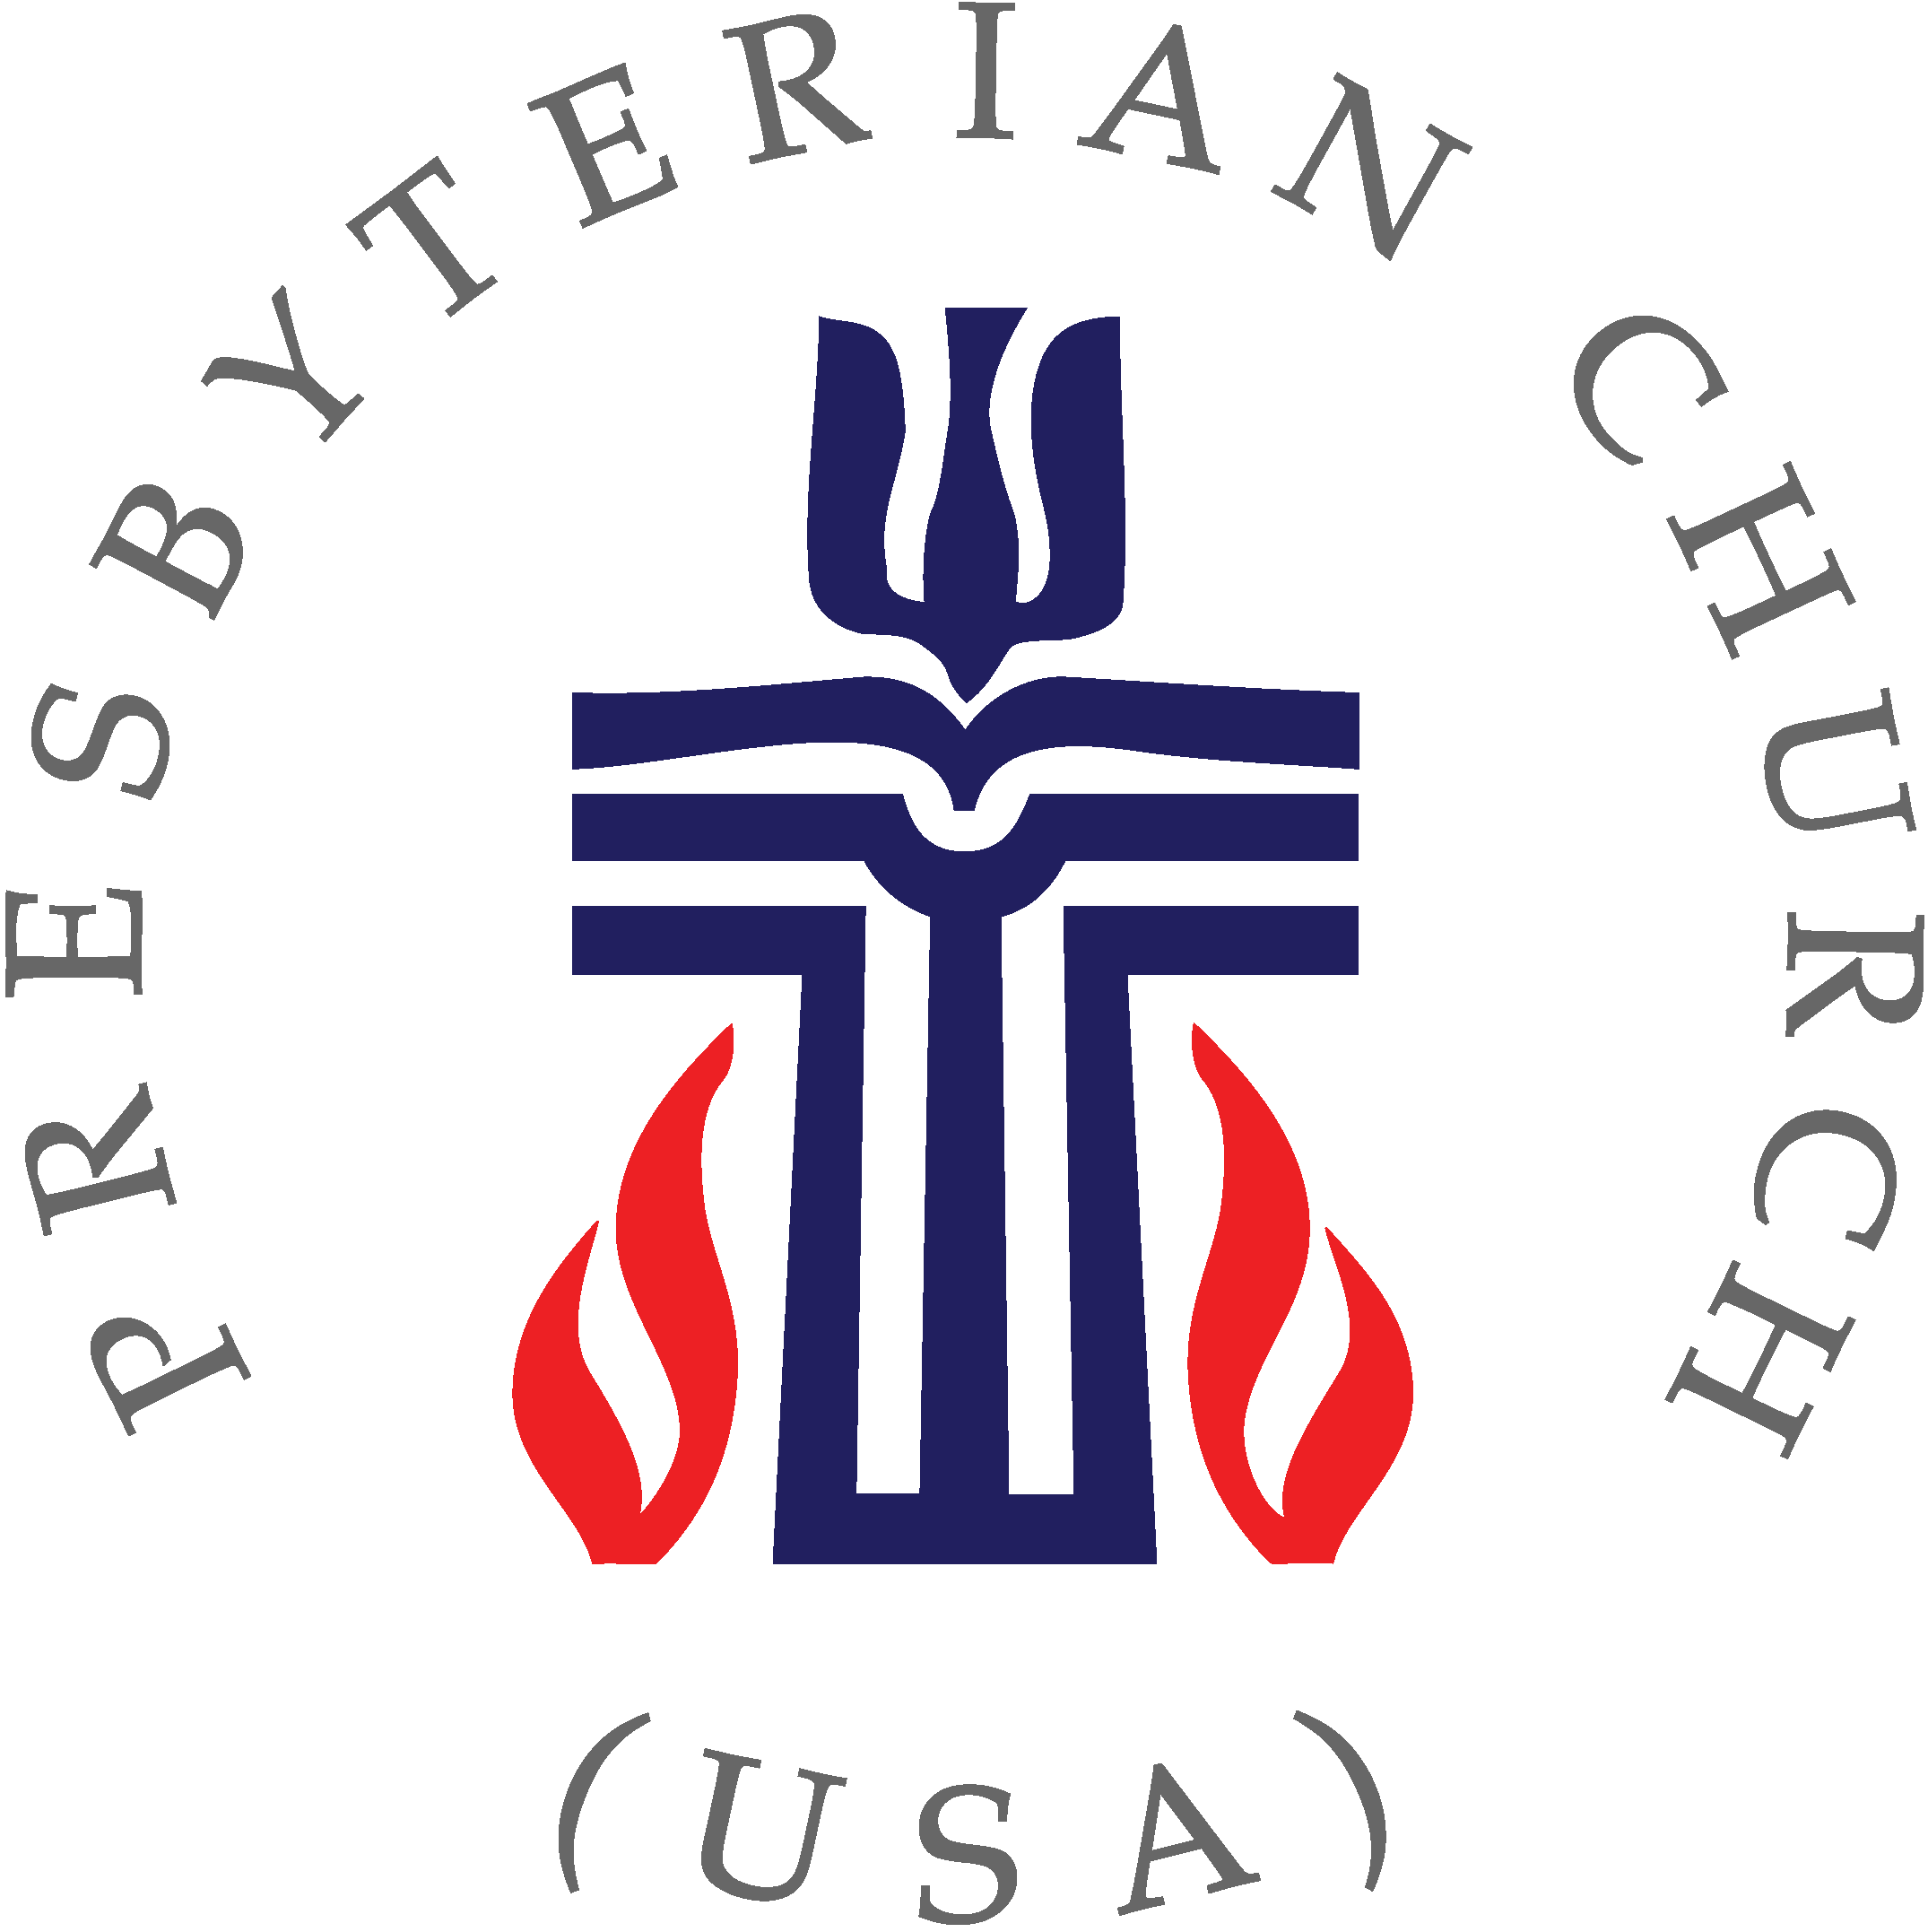

fpcwayne.com + fpcwayne@gmail.com + 402-375-2669
find us on Facebook at First Presbyterian Church - Wayne, Nebraska

