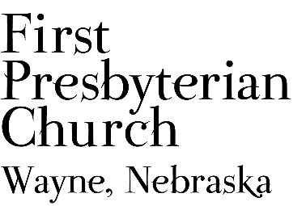

Presbytidings – November 2026
The Newsletter of First Presbyterian Church
216 West Third Street, Wayne, Nebraska 68787
(402) 375-2669 + www.fpcwayne.com
“Our chief end is to glorify and enjoy God forever.”

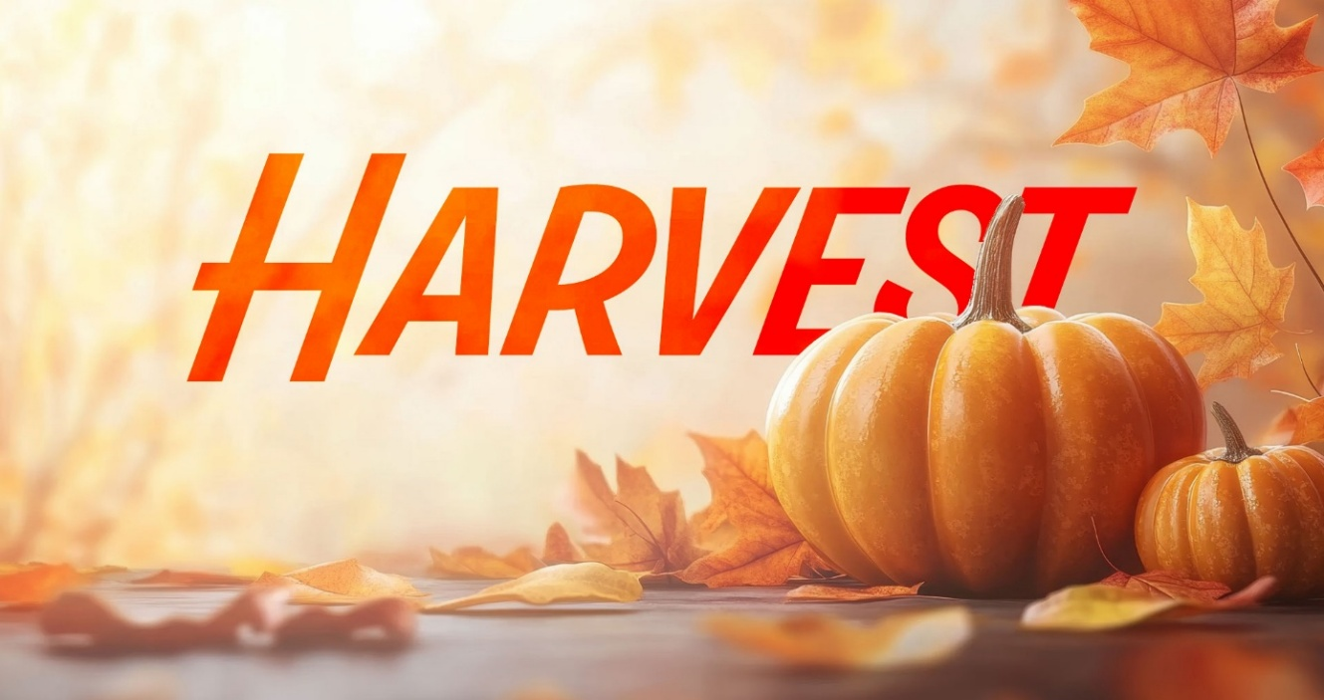

Join us at FPC for a sermon series entitled “Harvest,” beginning October 25th

Every field produces what has been planted, cultivated, and faithfully tended until maturity. Harvest is
never accidental. In the same way, our spiritual lives are continually yielding a harvest shaped by
our thoughts, our choices, our daily obedience to Christ. Are we producing a harvest that is pleasing
to God? Are we fixing our minds on what is true, noble, right, pure, admirable, excellent, and praiseworthy (Philippians 4:8)? If we give God access to the soil of our soul, allowing God to cultivate our hearts, God can produce in each of us a life that bears lasting fruit for God’s glory.

October 25th - Preparing the Soil
November 1st - Planting Good Seed
November 8th - Pulling the Weeds
November 29th - The Harvest is Ready

COMMUNION
We will celebrate the Lord’s Supper on November 1st. Mark Hammer is the communion elder. We will celebrate Communion on December 6th. Gail McCorkindale is the communion elder.

From the Pastor …


Pumpkin spice and caramel apple season have arrived! Pumpkin spice and caramel apples in candles, coffee, lattes, breads, muffins, the fragrances, and flavors of fall. The days are noticeable shorter, and the annual time change happens November 1st, when we “fall back.” I hope I’ve mowed the lawn for the last time this season, but don’t look forward to wrestling out the snowblower. Farmers have been busy bringing in the harvest between rain showers. There are days we don’t know whether to wear shorts or a sweatshirt or you start out with a sweatshirt and have to find a t-shirt before days end. I really enjoy fall, but don’t want to hurry it along. I’m reminded of the words of Ecclesiastes 3:1-13 NIV - There is a time for everything, and a season for every activity under the heavens…
Thanksgiving is just around the corner, and we have much to be thankful for here at FPC.
This is a season of activity and change at FPC. The newsletter points out the various activities of
FPC. The Tuesday Bible study continues under Gail’s leadership at Kinship Pointe, and all are
welcome to “drop in” and participate. The bell choir has started regular practices, and Sunday School for our kids has begun. The Deacons hosted a successful Coat Giveaway on October 10th, a big event, but it is really appreciated by the community. On October 24th, I participated in the first “Loads of Love” event sponsored by WACAM (Wayne Area Congregations and Ministers). We were at the Wash House Laundromat by Casey’s and assisted 12 folks with laundry products and quarters to wash and dry their laundry. Thanks to the congregation for their generous donation of $130.00 in quarters toward the project and the support of the Session. I think there will be another “Loads of Love” event in the future. FPC will be hosting a Trunk or Treat event on October 31st, in the new parking area from 4:00 p.m. to 6:00 p.m. All are welcome to join us, costumes are optional. Our last CoffeeHouse style worship will be on November 15th, and we will resume in February. Advent begins on November 29th, with Hanging of the Greens, also that day. As I write, Christmas is just 59 days away!
As you can read elsewhere in the newsletter, lots of improvements are happening around
our building and property, please be patient with interruptions in building use. All the improvements will beautify and make our building and grounds more functional. When I look back at the last month and look forward to November and December, I see many reasons to rejoice and give thanks. We are sharing our blessings as a community of faith when we reach out beyond our walls through our various programs and activities to others in our community.

Remember these words from 1 Peter 3:15 (NLT), Instead, you must worship Christ as Lord of your life. And if someone asks about your hope as a believer, always be ready to explain it. FPC is offering hope and an opportunity for each of us to share the reason for the hope we have in Jesus Christ.

Blessings,
Pastor Teresa

COFFEEHOUSE WORSHIP CONTINUES ON NOVEMBER 15th
We will meet in Fellowship Hall, and coffee and refreshments will be available, as desired, throughout the service. Mark Hammer has volunteered to be the Discussion Leader, but we are still in need of a Fellowship Host(s) for the day. This will be our last CoffeeHouse for the year. We will resume CoffeeHouse in February 2026.

RENOVATIONS AND CHANGES AT FPC
The Session recently approved several improvements to our building and grounds. Two off-street parking spaces have been added to the northwest corner of our property. This new space allows for a seamless transition from the parking space to the sidewalk or ramp. The change also leveled the area between the sidewalk, parking area, and alley to minimize tripping hazards. We hope to have the handicap markings and parking stripes added soon. We are seeking approval from the city to mark two street spaces as handicap parking on the west side of the building, just south of the new parking area, to give us a total of four handicap spaces.
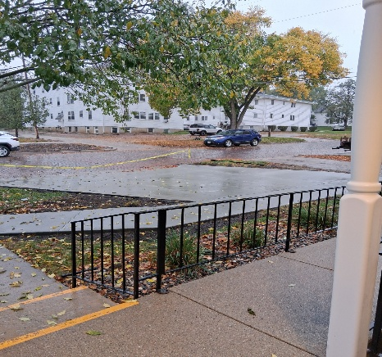
The Session also approved the installation of new carpet and painting of the Fellowship Hall, and new carpet on the back stairway. The sample board showing new carpet selections, paint, and how it coordinates with current sanctuary carpet has been on display in Fellowship Hall for a couple of weeks. The carpet selected is a nylon product in 12” X 48” planks from Flooring Solutions in Norfolk. This will allow for easy replacement of damaged or soiled carpet. We anticipate Flooring Solutions will be starting Fellowship Hall the first week of November. Thank you to Shari Dunklau and Amy Bowers who did the research on flooring options and presented them to the Session. The final project is the replacement of the furnace and air conditioner for Fellowship Hall. The unit was installed in 1993, per Zach's Heating & Cooling, and gave out this fall. The installation of the new furnace should be just in time for the temps to change in November. All of these projects improve our property in beauty and functionality.

BIBLE STUDY AT KINSHIP POINT
Gail McCorkindale is leading a Bible study on Tuesdays at Kinship Point at 1:15 p.m. Our journey of faith requires a growth of knowledge about the Bible. All are welcome to join Gail in this time of study.
HOMESTEAD PRESBYTERY
The Homestead Presbytery will meet on Thursday, November 19th, at Fourth Presbyterian Church of Lincoln between 10:00am-3:00pm. Speakers during the Education Hour are from Sleep in Heavenly Peace and Lincoln Hygiene Network.

SESSION MEETING
The Session will gather on Monday, November 23rd at 7:00pm in Fellowship Hall.

THANKSGIVING HOLIDAY HOURS
The First Presbyterian Church office, Wayne Food Pantry and Coat Closet will be closed November 26-27th for the Thanksgiving holiday.

PASTORAL COMMUNITY OUTREACH SERVICES
Pastor Teresa will lead pastoral outreach services at the following locations throughout October:
- WAYNE COUNTRY VIEW CHAPEL: Pastor will lead a chapel service at Country View on Sunday, November 1st.
- KINSHIP POINTE CHAPEL: Pastor Teresa will lead worship service with residents at Kinship Pointe at 3:00pm on Wednesday, November 11th.
- RADIO DEVOTIONS: Pastor Teresa will be giving daily devotions on 104.9 Big Red Country/ KTCH the week of November 23rd – 27th at 5:40am.
- The Wayne Herald: The Wayne Herald will have Pastor Teresa’s Word in Faith in the November 19th edition.

STEWARDSHIP REMINDER
Members and friends of the congregation should have received a year-to-date Statement of Giving for 2026 and a 2027 Intention of Giving form. If you did not receive this information, please contact Anita Fuelberth.
You are asked to prayerfully review your information and return the Intention of Giving form to Anita Fuelberth as soon as possible. You can mail the form to Anita or drop your envelope in the offering box at church. This information is helpful to the Session in planning for 2027. Thank You for your support and dedication to FPC.

DID YOU KNOW?
Qualified Charitable Distributions (QCDs) have become a great way for people 70½ or older to take all or part of their Required Minimum Distribution (RMD) from their Traditional IRA. The recent tax code changed the standard deduction for those over 65 to $26,600 for married filing jointly or $13,600 for single filers. Thus, for many of us, our church pledges will no longer be included in an itemized deduction. However, by making all or part of our pledge a Qualified Charitable Distribution directly from the IRA custodian or trustee to the church the distribution will not be included as taxable income to the IRA owner. Qualified Charitable Distributions can also exceed one's specific RMD amount and still not be taxed.
While Qualified Charitable Distributions are not complex there are certain requirements and steps that should be followed so check with your tax professional.

PRAYER FOR VETERANS DAY
God of peace, we pray for those who have served our nation,
who laid down their lives to protect and defend our freedom...
We pray for those who have fought, whose spirits and bodies are scarred by war
and whose nights are haunted by memories too painful for the light of day...
We pray for those who serve us now, especially for those in harm's way:
shield them from danger and bring them home, soon...
Turn the hearts and minds of our leaders and our enemies
to the work of justice and a harvest of peace...
Spare the poor, Lord, spare the poor!
May the peace you left us, the peace you gave us,
be the peace that sustains, the peace that saves us.
Christ Jesus, hear us! Lord Jesus, hear our prayer!
Amen.
From – ConcordPastor.blogspot.com

Deacons Coat Giveaway
….. ‘Truly I tell you, whatever you did for one of the least of these
brothers and sisters of mine, you did for me.’ Matthew 25:40b NIV

The First Presbyterian Church hosted a successful winter coat giveaway on October 10th in the church Fellowship Hall. The doors opened at 10 am for several people waiting and ready to find a winter coat for themselves or their families. One hundred coats, along with a variety of hats and gloves, went home with folks. The FPC Deacons are thankful for the assistance of the WCS FCCLA Club who moved the coats and racks from the lower level to Fellowship Hall and then returned them to the basement. The FPC Coat Closet is open Monday to Friday from 9 a.m. - noon. The closet accepts donation of new or used coats. Used coats should be clean and in good condition, zippers working etc. Please no wool or leather coats. For more information, call the church office at 402.375.2669.

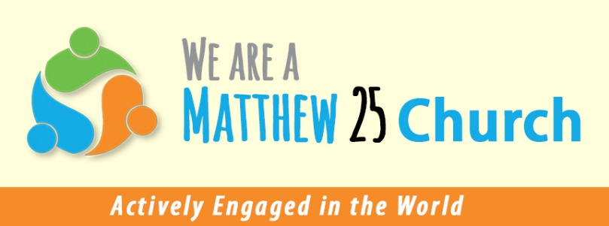

SALVATION ARMY BELL RINGERS NEEDED
The Wayne Extension Unit of the Salvation Army will be conducting its Annual Bell Ringing Campaign beginning Friday, November 27th. The bell ringing campaign is the primary fundraiser for the Salvation Army in Wayne. Bell ringers are needed for 1 or 2-hour time slots on Friday or Saturday beginning Thanksgiving weekend to December 24th. Churches, service organizations, youth groups and others are invited to participate in the bell ringing project. The only requirements are to be friendly and welcoming, dress warmly and smile easily and say thank-you, oh yeah, a little wrist action with a bell.
Ninety percent (90%) of the funds collected in the bell ringing campaign remain in the community and assist with housing, utilities, medical, transportation, and other needs of families and individuals in Wayne. In 2026, the Wayne SA Unit sponsored a Back-to-School Drive for school supplies for elementary children. The project was very successful and helped more than 98 children with backpacks and school supplies.
Participation in the Salvation Army bell ringing campaign is one way we can live into our commitment of being a Matthew 25 congregation; as we are reminded in Matthew 25:40; ‘… whatever you did for one of the least of these brothers and sisters of mine, you did for me.’
Please contact Pastor Teresa to volunteer to be a bell ringer at Pac N Save or Quality Foods Center. Thank you!

LOOKING AHEAD TO ADVENT & CHRISTMAS
- We will begin observing Advent on Sunday, November 29, 2026.
- The Hanging of the Greens on the interior and exterior of the building will take place after worship service on Sunday, November 29th. We would appreciate having volunteers remove the fall decorations from the Sanctuary and Fellowship Hall and setting up the Christmas tree sometime the week prior to the worship service on November 29th. Please contact Pastor Teresa or the church office if you can assist with the changeover of the seasons.
- Our Christmas Eve Service will be held at 5:30pm on December 24th.

ADVENT CANDLE LIGHTERS NEEDED
Pastor Teresa is looking for couples, families or individuals who would like to assist with lighting the Advent candles during worship. All readings will be provided in advance. Your participation in this seasonal tradition is appreciated! A sign-up sheet will be in Fellowship Hall or you can contact Pastor Teresa.
The dates are November 29th, December 6th, December 13th, December 20th, and December 24th.

To Give Thanks…
is to remember how it feels to experience belonging,
to look long around a laden table
and be glad to claim a place among that gathered company.
To give thanks is to remember what has been-time’s bewildering recital-
and, despite so much, to look ahead with undiminished hope.
To give thanks is to recall with heartache all those absent from the assembled,
the dear departed, those, too, who never made it in the first place,
due to loss, or want, foul fortune, being born at the wrong place, at the wrong time.
To give thanks takes all that we have been, all that we are and yet might be,
and shapes it new around a fuller, richer, broader future feast.
J. Barrie Shepherd

NOVEMBER BIRTHDAYS
(Would you like to see your birthday listed here?
Just contact the church office 402-375-2669 or fpcwayne@gmail.com)
6 Brandon B.
10 Kevin P.
12 Mark Mc.
13 Katherine B.
14 Audrey H.



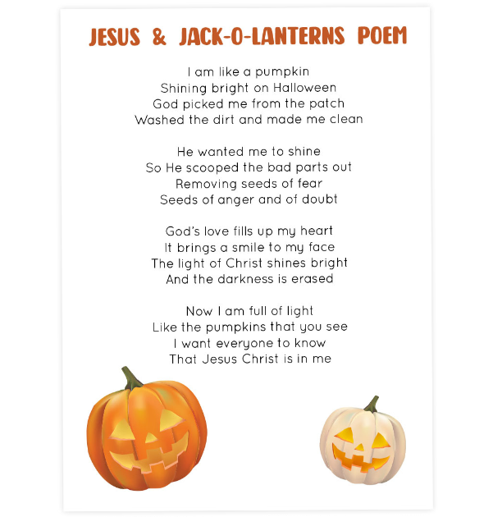

November 2026 – First Presbyterian Church

Sunday | Monday | Tuesday | Wednesday | Thursday | Friday | Saturday
1  Set your clocks  back one hour  Communion  1:30pm  Chapel at CountryView | 2 | 3  1:15pm  Kinship Bible Study with Gail | 4 | 5 | 6 | 7
8 | 9  9:30am  Wayne Family Coalition Meeting | 10  1:15pm  Kinship Bible Study with Gail | 11  10:30 am WACAM  Meeting  3:00pm Kinship Pointe  Worship | 12 | 13 | 14
15  10:00am  Coffeehouse Worship  Mark Hammer, Discussion Leader | 16 | 17  1:15pm  Kinship Bible Study with Gail | 18 | 19  10:00am  Homestead Presbytery in  Lincoln | 20 | 21
22 | 23  5:40am  KTCH 104.9 Moment for Living  7:00pm  Session Meeting | 24  5:40am  KTCH 104.9 Moment for Living  1:15pm  Kinship Bible Study with Gail | 25  5:40am  KTCH 104.9 Moment for Living | 26  5:40am  KTCH 104.9 Moment for Living  Thanksgiving Day  Office Closed | 27  5:40am  KTCH 104.9 Moment for Living  Office Closed | 28
29  Hanging of the Greens  First Sunday of Advent | 30

GET OUR NEWSLETTER BY E-MAIL
If you would like to receive this newsletter by e-mail (save a stamp, save a tree!), go to www.fpcwayne.com; on the home page, in the right-hand column, there is a widget that says, “NEWSLETTER SUBSCRIPTION: Enter your e-mail address to receive Presbytidings, our church’s newsletter, by e-mail.” Enter your address in the white box, and click on the button that says, “Sign me up!” You will need to confirm your subscription through an e-mail message that will be sent to your inbox; this is safe! It is designed to keep spammers out of the picture! Share our newsletter with all your friends and family. Simple!
Contact Information:
First Presbyterian Church
216 W. Third Street
Wayne NE 68787

FPC Office/Wayne Food Pantry/Coat Closet
402-375-2669
fpcwayne@gmail.com
Tuesday – Friday, 9am – 12 noon

Pastor Teresa Bartlett
402-375-2669 (office)
319-795-2911 (cell)

Websites:
Church: https://fpcwayne.com/
Wayne Food Pantry: https://fpcwayne.com/food-pantry/
Wayne Coat Closet:
https://fpcwayne.com/wayne-coat-closet/



FIND US ON FACEBOOK
First Presbyterian Church – Wayne, Nebraska
Wayne Food Pantry – Wayne, Nebraska
Wayne Coat Closet - First Presbyterian Church

FPC Service Recordings can be found at:
*Facebook @ First Presbyterian Church – Wayne, Nebraska
*Our website @ https://fpcwayne.com
*YouTube @ FPC of Wayne Nebraska

FPC Online Worship Bulletins can be found at:
https://fpcwayne.com/fpc-wayne-worship-bulletins/

FPC Account at Thrift Warehouse: #4570

